**MAIN PROJECT REPORT**

**ON**

**“CONTRACTO”**

*In Partial fulfillment of the requirements*

*For the award of the degree of*

**BACHELOR OF COMPUTER APPLICATIONS**

(VIth SEMESTER)

**DONE BY**

**SNEHAL BIJU (Reg. No.: 200021094413)**

*Under the guidance of*

**Mr. Surej J. Kappen**

(Asst. Professor)



**Department of Computer Science**

**ST.JOSEPH’S ACADEMY OF HIGHER EDUCATION AND RESEARCH, MOOLAMATTOM**

*(Affiliated to Mahatma Gandhi University)*

2022-2023

**ST. JOSEPH’S ACADEMY OF HIGHER EDUCATION AND RESEARCH, MOOLAMATTOM**

*(Affiliated to Mahatma Gandhi University***)**



**Department of Computer Science**

**CERTIFICATE**

*Certified that this is a bonafide report of the Project Work with the topic* ***“CONTRACTO”*** *for St. Joseph’s Academy of Higher Education and Research, Moolamattom done by* ***Snehal Biju******(Reg. No: 200020194413)*** *during the year 2022-2023 in partial fulfillment of the requirements for the award of the degree of Bachelor of Computer Applications of Mahatma Gandhi University, Kottayam, Kerala.*

**Principal Head of the Department Project Guide**

Submitted for the Viva-Voce Examination held on ………………

**External Examiner**

**ACKNOWLEDGEMENT**

I give all the honors and praise to The Lord, giving me the wisdom and enabling me to complete this project successfully.

I express my sincere gratitude to **Dr. Thomson Joseph,** thebeloved principal, providing the support and the necessary facilities for completion of this project successfully.

I thank profusely **Mr. Geo Kurian,** Head, The Department of Computer Science, for his extended guidance and inspiration, throughout the course of the study.

I express my sincere gratitude to the Project Guide **Mr. Surej J. Kappen,** Assistant professor, The Department of Computer Science, for the valuable advices and guidance throughout the completion of the project.

I express my gratitude to all the Faculties, the Lab Assistant, and the Friends for their sincere and friendly cooperation in the successful completion of my project.

Snehal Biju

(Reg. No. 200021094413)

|  |  |  |
| --- | --- | --- |
|  | **INDEX** |  |
| **Sl.No.** | **Topics** | **Page No.** |
| 1. | Introduction | 2 |
| 2. | System Analysis | 4 |
|  | 2.1 Existing System | 5 |
|  | 2.2 Proposed System | 5 |
| 3. | Software Requirements Specification | 8 |
|  | 3.1 User Requirements | 8 |
|  | 3.2 Functional Requirements | 8 |
|  | 3.3 Non-Functional Requirements | 9 |
|  | 3.4 System Requirements | 10 |
|  | 3.4.1 Hardware Specification | 10 |
|  | 3.4.2 Software Specification | 10 |
| 4. | Feasibility Analysis | 17 |
|  | 4.1 Technical Feasibility | 17 |
|  | 4.2 Operational Feasibility | 18 |
|  | 4.3 Economic Feasibility | 18 |
| 5. | Data Flow Diagram | 21 |
| 6. | Table Design | 34 |
| 7. | System Design | 44 |
|  | 7.1 Input Design | 44 |
|  | 7.2 Output Design | 45 |
| 8. | System Testing and Implementation | 47 |
|  | 8.1 Unit Testing | 48 |
|  | 8.2 Integration Testing | 48 |
|  | 8.3 Validation Testing | 48 |
|  | 8.4 Implementation | 48 |
| 9. | Maintenance | 50 |
| 10. | Conclusion | 52 |
| 11. | Bibliography | 54 |
| 12. | References | 56 |
| 13. | Screenshots | 58 |

1. **INTRODUCTION**

**1.INTRODUCTION**

The project titled “Contracto” is to make a dynamic website and an android application for a helping people related to construction works. The project offers a flexible way to manage construction and real estate related functionalities.

There are four types of users for the project: The Admin, Contractor, Client, and Landlord. Admin has over all control on the system. Clients will post construction related works in the website. Contractors can request for doing a work. The clients can also search plots and buy them from the landlords.

1. **SYSTEM ANALYSIS**

**2. SYSTEM ANALYSIS**

Software Engineering is the analysis, design, construction, verification and management of technical or social entities. To engineer software accurately, a software engineering process must be defined. System analysis is a detailed study of the various operations performed by the system and their relationship within and module of the system. It is a structured method for solving the problems related to the development of a new system. The detailed investigation of the present system is the focal point of system analysis. This phase involves the study of parent system and identification of system objectives. Information has to be collected from all people who are affected by or who use the system. During analysis, data are collected on the variable files, decision point and transactions handled by the present system. The main aim of system is to provide the efficient and user-friendly automation. So, the system analysis process should be performed with extreme precision, so that an accurate.

System analysis involves gathering the necessary information and using the structured tool for analysis. This includes the studying existing system and its drawback, designing a new system and conducting cost benefit analysis. System analysis is a problem-solving activity that requires intensive communication between the system users and system developers. The system is studied to the minute detail and analysed. The system is viewed as a whole and the inputs to the system are identified. The outputs from the organization are traced through various phases of processing of inputs. There are a number of different approaches to system analysis. When computer bases information system is developed, systems analysis (according to the Waterfall model) would constitute the following steps:

* The development of a feasibility study, involving determining whether a project is technologically and operationally feasible.
* Conducting fact-finding measures, designed to ascertain the requirements of the system’s end-users. These typically span interviews, questionnaires, or visual observations of work on the existing system.
* Gauging how the end-users would operate the system (in terms of general experience in using computer hardware or software), what the system would be used for and so on.

Techniques such as interviews, questionnaires etc, can be used for the detailed study of these processes. The data collected by these sources must be scrutinized to arrive at a conclusion. The conclusion is an understanding of how the system functions. This system is called the Existing System. The Existing system is then subjected to close observation and the problem areas are identified. The designer now functions as a problem solver and tries to sort out the difficulties that the enterprise faces. The solutions are given as a proposal which is the Proposed System. The proposal is then weighed with the existing system analytically and the best one is selected. The proposal is then presented to the user for an endorsement by the user. The proposal is reviewed on user request and suitable changes are made. This is a loop that ends as soon as the user is satisfied with the proposal.

**2.1 Existing System**

In the existing system some contractors find it difficult to find new job opportunities. The main reason behind this is limited network. Contractors who have a limited network of industry contacts may struggle to find new job opportunities. Finding a good contractor can be a difficult task for clients in the construction industry. There are various reasons for this difficulty, including lack of transparency in pricing and scope of work, quality concerns, limited options, limited knowledge of the industry, and time constraints. Clients must do their research, ask for references, and thoroughly vet potential contractors before hiring them.

**Disadvantages of Existing System**

* Difficulty in finding new job opportunities.
* Lack of transparency in pricing and scope of work.
* Difficulty in finding a good contractors.

**2.2 Proposed System**

To eliminate the difficulties caused by the existing system, this new proposed system helps the clients to post their required works in the system and the contractors who are interested can request to do the work. In response to the requests clients can select a contractor who can satisfy their requirements. Since, all deadlines and construction amounts are already set there is no worry about this too. Another advantage is that this system supports real-time chat support among the clients and contractors. In addition this system also allows various landlords to register in this system and sell their plots to other users.

**Advantages of proposed system**

* Improved transparency in pricing and scope of work.
* Client can choose good contractor from a set of contractors.
* Can easily find new job opportunities.
* Real-time chat option for client and contractor.
* Also allows users to sell their property through the system.

**3. SOFTWARE REQUIREMENTS SPECIFICATION**

**3. SOFTWARE REQUIREMENTS SPECIFICATION**

A software requirements specification (SRS) is a comprehensive description of the intended purpose and the environment for software under development. The SRS fully describes what the software will do and how it will be expected to perform. As SRS minimizes the time and effort required by developers to achieve desired goals and also minimizes the development cost. A good SRS defines how an application will system hardware, other programs and human users in a wide variety of real-world situation.

**3.1 User Requirements**

There are three types of users in this system-Admin, Client, Contractor, and Landlord. The admin needs to get the deatails of employees and overall working functioning of the website. Client needs to search plot, and post his works in the website. Contractors can search available works and apply for them. The Landlords need to put the details of the plots under them so that the consumers can buy them.

**3.2 Functional Requirements**

* All type of users should be able to login to the system.
* The software should help the admin accepting or rejecting contractor and landlord registration requests and view and reply to complaints and feedbacks.
* The software should help the landlords to put the details of plots and they should be able to find who all are requested for their plots.
* Clients should be able to post their works and search plots in order to buy them.
* Contractors should be able to search for works and send requests to do the work.

|  |  |
| --- | --- |
| Admin | * Should be able to add, delete locations and category of works. * Should be able view and respond to complaints. * Should be able to view contractor and landlord registration requests and accept, reject requests. * Should be able to view feedbacks. |
| Client | * Should be able to post works. * Should be able to approve works. * Should be able to search available plots. * Should be able to view whether plot request has been approved. * Should be able to edit profile. * Should be able to make complaints and feedbacks. * Should be able to chat with contractor. |
| Contractor | * Should be able to search works. * Should be able to view whether work request has been approved or not. * Should be able to edit profile. * Should be able to make complaints and feedbacks. * Should be able to chat with contractor. |
| Landlord | * Should be able to create account. * Should be able to post plot details. * Should be able to post his/her complaints and feedback * Should be able to view requests for the plot. * Should be able to edit profile. |

**3.3 Non-Functional Requirements**

Functional requirements specify what a system is supposed to do whereas non- functional requirements define how a system is supposed to be. Non-functional requirements are often called qualities of a system.

* Performance: It helps the users access the system quickly.
* Compatibility: The system is supported in Chrome, Microsoft edge, Firefox etc.
* Efficiency: Users can do their tasks quickly.
* Learnability: User friendly interface is provided which helps users to learn and use system quickly.
* Usability: The system is easy to learn without a tutorial and allows users to accomplish their goals without errors.

**3.4 System Requirements**

To be used efficiently, all computer software needs certain hardware component or other software resources to be present on a system. These prerequisites are known as system requirements and are often used as a guideline as opposed to an absolute rule.

**3.4.1 Hardware Specification**

Hardware is the term used to describe the electrical and electronic components that make up a computer system. The most common set of requirements defined by any operating system or software application is the physical computer resources, also known as hardware. A hardware requirement list is often accompanied by a hardware compatibility list (HCL), especially in case of operating systems. An HCL lists tested, compatible, and sometimes incompatible hardware devices for a particular operating system or application.

Processor: Intel Pentium or above

Hard Disk: up to 200 MB of available space may be required

Display Type: PC Display

Keyboard: PC/AT Enhanced PS/2Keyboard (110/10Key)

Mouse: First/Pilot Mouse Serial(c48) / Touchpad

Input Device: Mouse, Keyboard

Output Device: Monitor

**3.4.2 Software Specification**

The software requirements specification document enlists all necessary requirements that are required for the project development. To derive the requirements, we need to have clear and thorough understanding of the products to be developed. This is prepared after detailed communication with the project

Operating System: Windows 10 or above for better performance

Front end: HTML5, CSS3.0, Javascript, Android (for mobile application).

Back end: MySQL, JSP

IDE: NetBeans IDE 8.1

Software: Wamp server

Web browser: Internet explorer/Google chrome/Firefox

Web server: Apache

**3.4.2.1 WINDOWS 10**

Operating system is defined as a program that manages the computer hardware. An OS can be viewed as a scheduler, where it has resources for which it has change. Resource include CPU, memory, I/O device and disk space. In another view, the OS is a new machine. The third view is that the OS is a multiplexer which allows sharing of resources provides protection from interference and provides a level of cooperating between users. This project is developed using Windows 10 as the OS and supports its latest version. Windows 10 is a series of personal computer OS produced by Microsoft as part of its Windows NT family of OS. Windows 10 received mostly positive reviews upon its original release in July 2015.

One of Windows 10’s most notable features is support for universal apps. Windows 10 also introduced the Microsoft Edge web browser, a virtual desktop system, a window and desktop management feature called Task View, support for fingerprint and face recognition login, new security features for enterprise environments, and DirectX12. Windows 10 received mostly positive reviews upon its original release in July 2015. Critics praised Microsoft’s decision to provide a desktop-oriented interfacing line with previous versions of Windows, contrasting the tablet-oriented approach of 8, although Windows 10’s touch- oriented user interface mode was criticized for containing regressions upon the touch-oriented interface of Windows 8. Critics also praised the improvements to Windows 10’s bundled software over Windows 8.1. Xbox Live integration, as well as the functionality and capabilities of the Cortana personal assistant and the replacement of Internet Explorer with Microsoft Edge. However, media outlets have been critical of changes to operating system behaviours, including mandatory update installation, privacy concerns over data collection performed by the OS for Microsoft and its partners and the adware-like tactics used to promote the operating system on its release,

**3.4.2.2 HTML5**

HTML stands for Hyper Text Markup Language. It is the standard markup language for creating Web pages. HTML describes the structure of a Web page. It consists of a series of elements.HTML elements tell the browser how to display the content

HTML5 is the next major revision of the HTML standard superseding HTML 4.01, XHTML 1.0, and XHTML 1.1. HTML5 is a standard for structuring and presenting content on the World Wide Web.

HTML5 is a cooperation between the World Wide Web Consortium (W3C) and the Web Hypertext Application Technology Working Group (WHATWG).

The new standard incorporates features like video playback and drag-and-drop that have been previously dependent on third-party browser plug-ins such as Adobe Flash, Microsoft Silverlight, and Google Gears.

**3.4.2.3 CSS 3.0**

Cascading Style Sheets (CSS) is a simple mechanism for adding style (e.g., fonts, colors, spacing) to Web documents.

**CSS3** is the latest evolution of the Cascading Style Sheets language and aims at extending CSS2.1. It brings a lot of new features and additions, like rounded corners, shadows, gradients, transitions or animations, as well as new layouts like multi-columns, flexible box or grid layouts.

**3.4.2.4 JAVASCRIPT**

JavaScript is a lightweight, interpreted programming language. It is designed for creating network-centric applications. It is complimentary to and integrated with Java. JavaScript is very easy to implement because it is integrated with HTML. It is open and cross-platform.

Applications of JavaScript

* Client-side validation - This is really important to verify any user input before submitting it to the server and Javascript plays an important role in validting those inputs at front-end itself.
* User Notifications - You can use Javascript to raise dynamic pop-ups on the webpages to give different types of notifications to your website visitors.
* Back-end Data Loading - Javascript provides Ajax library which helps in loading back-end data while you are doing some other processing. This really gives an amazing experience to your website visitors.
* Server Applications - Node JS is built on Chrome's Javascript runtime for building fast and scalable network applications. This is an event based library which helps in developing very sophisticated server applications including Web Servers.

**3.4.2.5 JSP**

JSP stands for JavaServer Pages. It is a technology used to create dynamic web pages in Java by embedding Java code within HTML or XML documents. JSP pages are compiled into servlets when they are accessed for the first time, and this servlet code is then executed on the server to generate the dynamic content that is sent back to the client browser.

JSP pages are often used in combination with Java Servlets, which are server-side programs that provide a framework for handling client requests and generating dynamic web content. Together, JSP and Servlets provide a powerful platform for building web applications in Java.

JSP can be used to create a wide range of web applications, from simple websites to complex enterprise-level systems. It is widely used in industry for building scalable and robust web applications due to its flexibility and ease of use.

**3.4.2.6 MySQL**

MySQL is the world’s most popular open-source database software, with over 100 million copies of its software downloaded or distributed throughout its history. With its superior speed, reliability and ease of use, MySQL has become the preferred choice for Web, Web 2.0, SaaS, ISV. Telecom companies and forward-thinking cooperate IT Managers because it eliminates the major problems associated with downtime, maintenance and administration for modern, online applications.

MySQL is a database management system. A database is a structured collection of data. It may be anything from a simple shopping list to a picture gallery or the vast amounts of information in a corporate network. To add, access, and process data stored in a computer database, you need a database management system such as MySQL server. MySQL is a client server model relational database management system which supports structured query language. Structured query language is the set of commands that allows to modify or retrieve information from the database. Client server means that MySQL is designed to store data in the central location and deliver it on demand to numerous clients.

**3.4.2.7 WAMP SERVER**

WAMP Server is a Windows web development environment. It allows you to create web applications with Apache2, PHP and a MySQL database. Alongside, PhpMyAdmin allows you to manage easily your databases. WAMP Server refers to a software stack for the Microsoft Windows operating system, created by Romain Bourdon and consisting of the Apache web server. Open SSL. For SSL support, MySQL database and PHP programming language. WAMP Server is a Web development platform on Windows that allows you to create dynamic Web applications with Apache2, PHP, MySQL and MariaDB. WampServer automatically installs everything you need to intuitively developed Web applications. You will be able to tune your server without even touching its setting files.

Wamp is an acronym that stands for Windows, Apache, MySQL. It’s a software stack which means installing WAMP installs Apache, MySQL on your operating system (Windows in the case of WAMP). Even though you can install them separately, they are usually bundled up, and for a good reason too. WAMP acts like a virtual server on your computer. It allows you to test all WordPress features without any consequences since it’s localized on your machine and is not connected to the web. First of all, this means that you don’t need to wait until files are uploaded to your site, and secondly – this makes creating backups much easier.

**3.4.2.8 NetBeans IDE**

NetBeans IDE is an open-source integrated development environment (IDE) used by developers to build applications in various programming languages such as Java, C/C++, PHP, and HTML5. NetBeans is widely used in industry and is known for its intuitive user interface, powerful tools, and flexibility.

Here are some key features of NetBeans IDE:

1. Cross-platform support: NetBeans IDE is available on Windows, Mac, Linux, and other operating systems, making it a versatile tool for developers.

2. Code editing: NetBeans IDE provides advanced code editing features such as syntax highlighting, auto-completion, and code formatting to help developers write clean and efficient code.

3. Code debugging: NetBeans IDE provides a powerful debugger that allows developers to step through their code, set breakpoints, and inspect variables to find and fix bugs.

4. Project management: NetBeans IDE makes it easy to manage large projects by providing features such as project templates, code navigation, and source control integration.

5. Plugin support: NetBeans IDE has a rich plugin ecosystem that allows developers to extend its functionality for various purposes, such as adding support for new languages, frameworks, and tools.

6. GUI development: NetBeans IDE includes a drag-and-drop GUI builder that allows developers to create user interfaces quickly and easily.

7. Testing: NetBeans IDE provides integrated support for unit testing and integration testing, making it easier for developers to ensure the quality of their code.

**3.4.2.9 Android**

Android is a mobile operating system based on a modified version of the Linux kernel and other open-source software, designed primarily for touchscreen mobile devices such as smartphones and tablets. Android is developed by a consortium of developers known as the Open Handset Alliance, though its most widely used version is primarily developed by Google. It was unveiled in November 2007, with the first commercial Android device, the HTC Dream, being launched in September 2008.

At its core, the operating system is known as Android Open Source Project (AOSP) and is free and open-source software (FOSS) primarily licensed under the Apache License. However most devices run on the proprietary Android version developed by Google, which ship with additional proprietary closed-source software pre-installed, most notably Google Mobile Services (GMS) which includes core apps such as Google Chrome, the digital distribution platform Google Play, and the associated Google Play Services development platform. While AOSP is free, the "Android" name and logo are trademarks of Google, which imposes standards to restrict the use of Android branding by "uncertified" devices outside their ecosystem.

**4. FEASIBILITY ANALYSIS**

**4. FEASIBILITY ANALYSIS**

Feasibility is defined as the practical extent to which a project can be performed successfully. To evaluate feasibility, a feasibility study is performed, which determines whether the solution considered to accomplish the requirements is practical and workable in the software. Information such as resource availability, cost estimation for software development, benefits of the software to the organization after it is developed and cost to be incurred on its maintenance are considered during the feasibility study. The objective of the feasibility study is to establish the reasons for developing the software that is acceptable to users, adaptable to change and conformable to established standards. Various other objectives of feasibility study are listed below.

* To analyse whether the software will meet organizational requirements.
* To determine whether the software can be implemented using the current technology and within the specified budget and schedule.

Referencing to this information, we do a studies and discussions about whether the desired system and its functionality are feasible to develop and the output of this phase is a feasibility study report that should contained adequate comments and recommendations. Various types of feasibility that we checked include technical feasibility, operational feasibility, and economic feasibility.

**4.1 Technical Feasibility**

Technical feasibility assesses the current resources (such as hardware and software) and technology, which are required to accomplish user requirements in the software within the allocated time and budget. For this, the software development team ascertains whether the current resources and technology can be upgraded or added in the software to accomplish specified user requirements. Technical feasibility also performs the following tasks.

* Analyses the technical skills and capabilities of the software development team members.
* Determine whether the relevant technology is stable and established.
* Ascertains that the technology chosen for software development has a large number of users so that they can be consulted when problems arise or improvements are required.

From my perspective there are three languages HTML5, Javascript, JSP and database MySQL which are used to develop this web base applications. Android is used to create mobile based application for the website. HTML5 and Javascript are used in the front end and MySQL, PHP are used in the back end. The Word to the Wise is web based and thus can be accessed through any browsers. As we are using these latest technologies which are currently trending and used by a number of developers across the globe, we can say that our project is technically feasible.

**4.2 Operational Feasibility**

Operational feasibility assesses the extent to which the required software performs a series of steps to solve business problems and user requirements. This feasibility is dependent on human resources (software development team) and involves visualizing whether the software will operate after it is developed and be operative once it is installed. Operational feasibility also performs the following tasks.

* Determines whether the problems anticipated in user requirements are of high priority.
* Determines whether the solution suggested by the software development team is acceptable.
* Analyses whether users will adapt to a new software.
* Determines whether the organization is satisfied by the alternative solutions proposed by the software development team.

We found that our project will be satisfied for the client since we were discussing every detail about the software with the client at every step. The most important part of operational feasibility study is the input from client. So, the software is built completely according to the requirements of the client. We have used the current industry standards for the software. Hence, we can say that this software is operationally feasible.

**4.3 Economic Feasibility**

Economic feasibility determines whether the required software is capable of generating financial gains for an organization. It involves the cost incurred on the software development team, estimated cost of hardware and software, cost of performing feasibility study, and so on. For this, it is essential to consider expenses made on purchases (such as hardware purchase) and activities required to carry out software development. In addition, it is necessary to consider the benefits that can be achieved by developing the software. Software is said to be economically feasible if it focuses on the issues listed below.

* Cost incurred on software development to produce long-term gains for an organization.
* Cost required to conduct full software investigation (such as requirements elicitation and requirements analysis).
* Cost of hardware, software, development team, and training.

It is estimated that our project is economically feasible as development cost is very minimal since the tools and technologies used are available online. It’s a group student project so there are no personnel costs. Development time is well planned and will not affect other operations and activities of the individuals. Once the system has been developed, the companies purchasing the system will be providing with a manual for training purposes. There is no need to purchase new hardware since the existing computers can still be used to implement the new system.

**5. DATA FLOW DIAGRAM**

**5. DATA FLOW DIAGRAM**

A Data Flow Diagram (DFD) is a traditional visual representation of the information flows within a system. A neat and clear DFD can depict the right amount of the system requirement graphically. It can be manual, automated, or a combination of both. It shows how data enters and leaves the system, what changes the information, and where data is stored.

The objective of a DFD is to show the scope and boundaries of a system as a whole. It may be used as a communication tool between a system analyst and any person who plays a part in the order that acts as a starting point for redesigning a system. The DFD is also called as a data flow graph or bubble chart.

**Symbols and Notations Used in DFDs**

|  |  |
| --- | --- |
|  | **External entity:** an outside system that sends or receives data, communicating with the system being diagrammed. They are the sources and destinations of information entering or leaving the system. They might be an outside organization or person, a computer system or a business system |
|  | **Process:**any process that changes the data, producing an output. It might perform computations, or sort data based on logic, or direct the data flow based on business rules. |
|  | **Data store:** files or repositories that hold information for later use, such as a database table or a membership form. |
|  | **Data flow:** the route that data takes between the external entities, processes and data stores |

**CONTEXT LEVEL DIAGRAM FOR CONTRACTO**

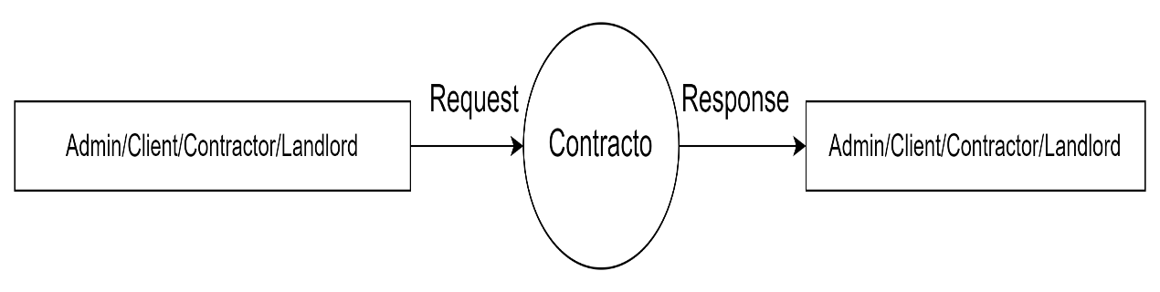

Fig: Context level DFD for Contracto

**FIRST LEVEL DIAGRAM FOR CONTRACTO**

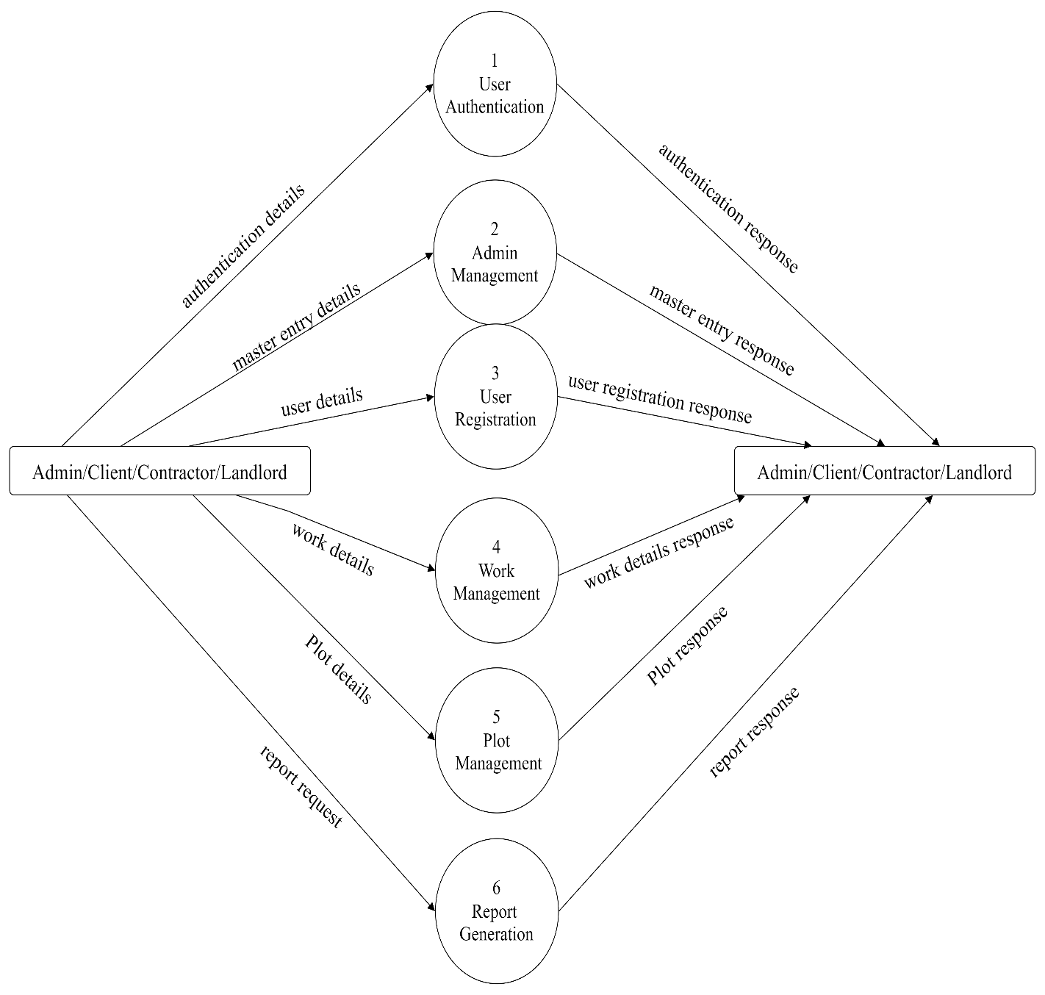

**LEVEL 2 DFD**

* 1. **ADMIN LOGIN**

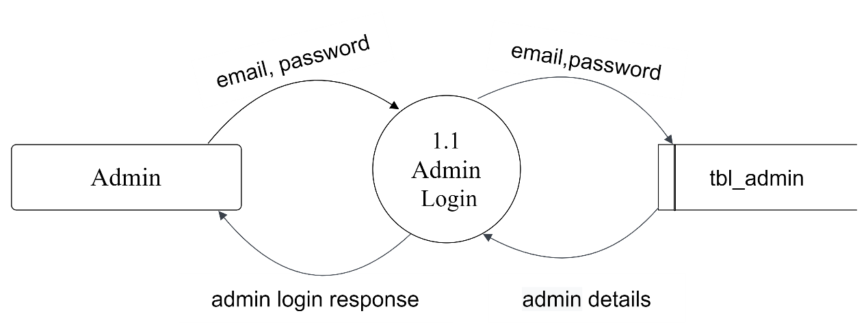

Fig: Second level DFD for Admin Login

* 1. **CLIENT LOGIN**

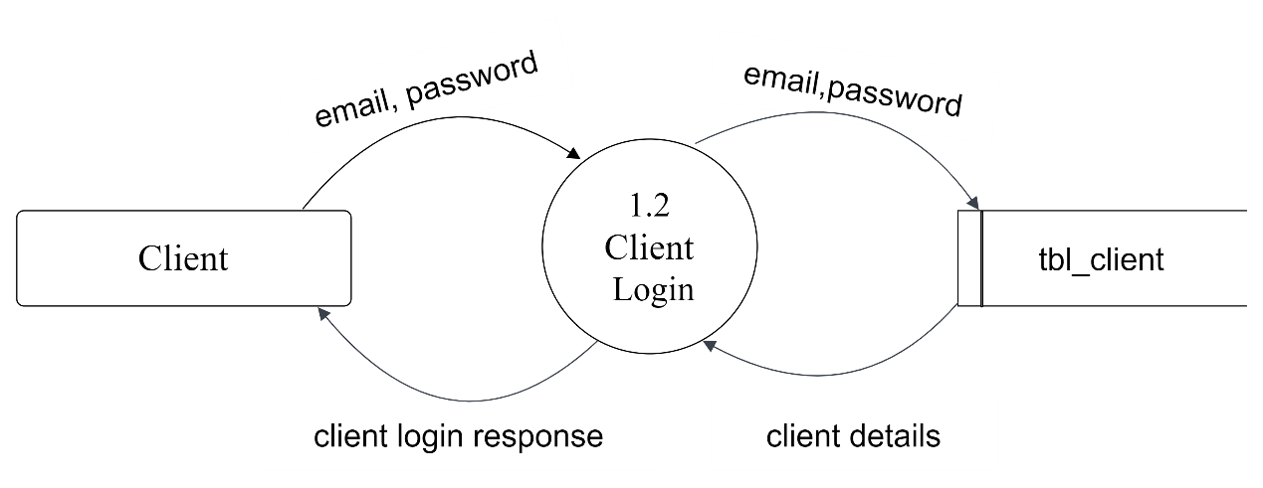

Fig: Second level DFD for Client Login

* 1. **CONTRACTOR LOGIN**

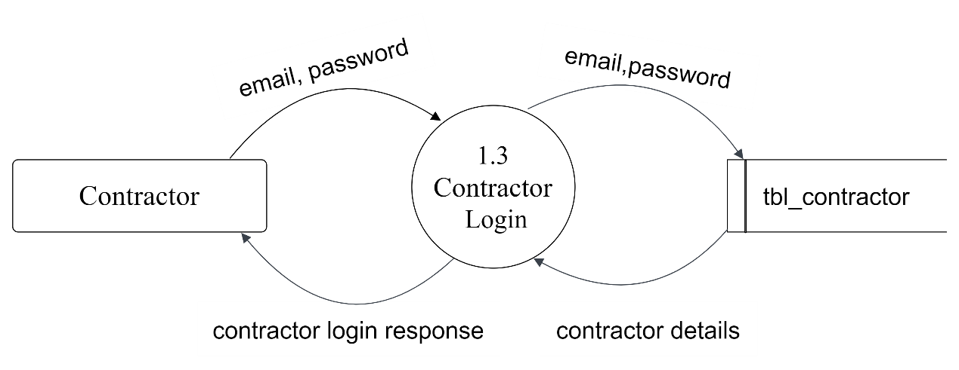

Fig: Second level DFD for Contractor Login

* 1. **LANDLORD LOGIN**

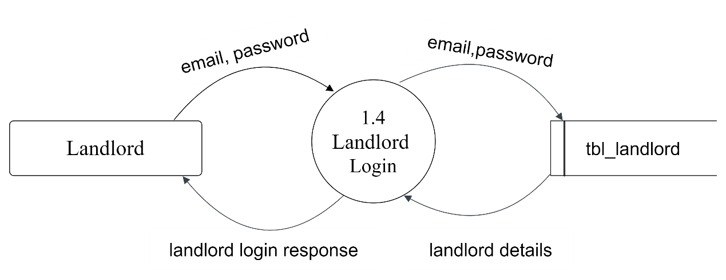

Fig: Second level DFD for Landlord Login

**LEVEL 2 DFD**

**2.1 PLACE REGISTRATION**

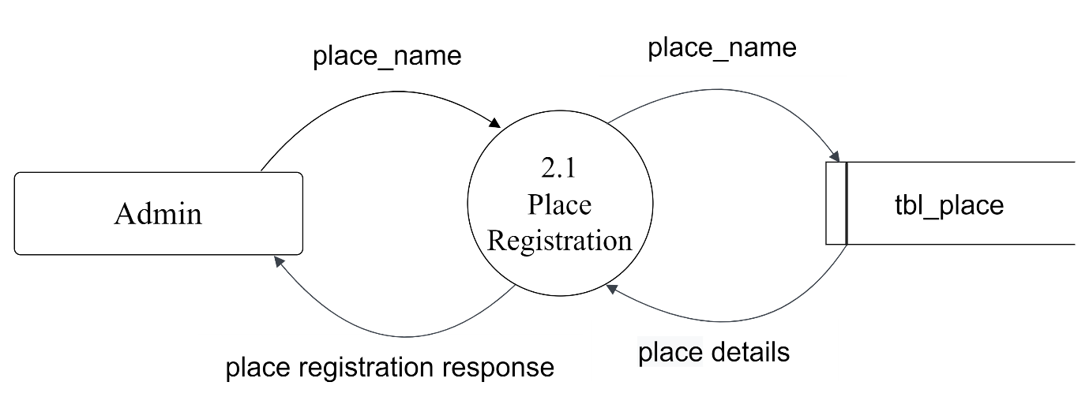

Fig: Second level DFD for Place Registration

**2.2 DISTRICT REGISTRATION**

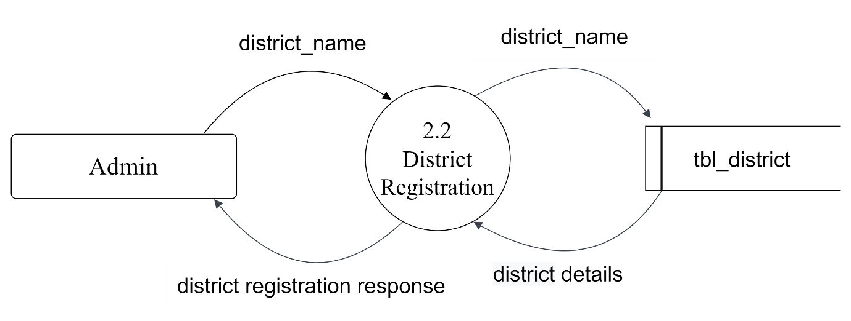

Fig: Second level DFD for District Registration

**2.3 CATEGORY REGISTRATION**

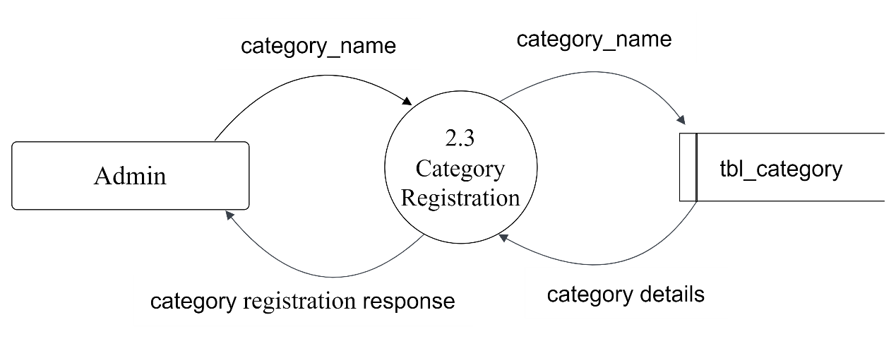

Fig: Second level DFD for Category Registration

**2.4 CONTRACTOR APPROVAL/REJECTION**

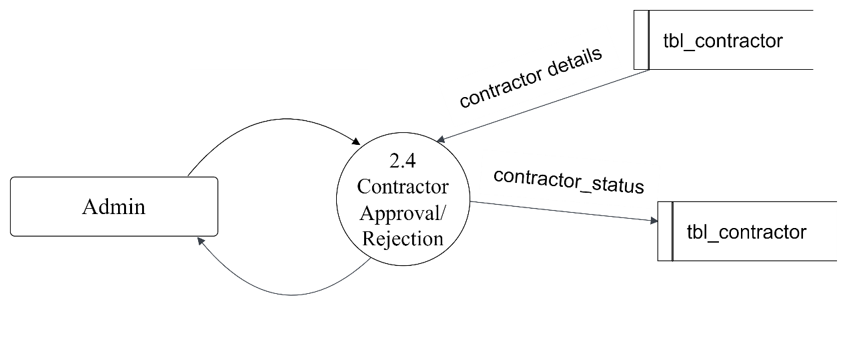

Fig: Second level DFD for Contractor Approval/Rejection

**2.5 LANDLORD APPROVAL/REJECTION**

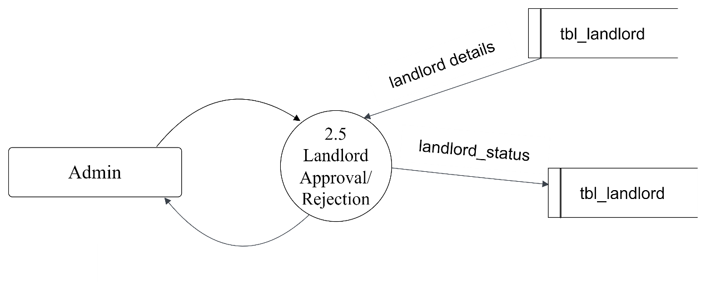

Fig: Second level DFD for Landlord Approval/Rejection

**LEVEL 2 DFD**

**3.1 CLIENT REGISTRATION**

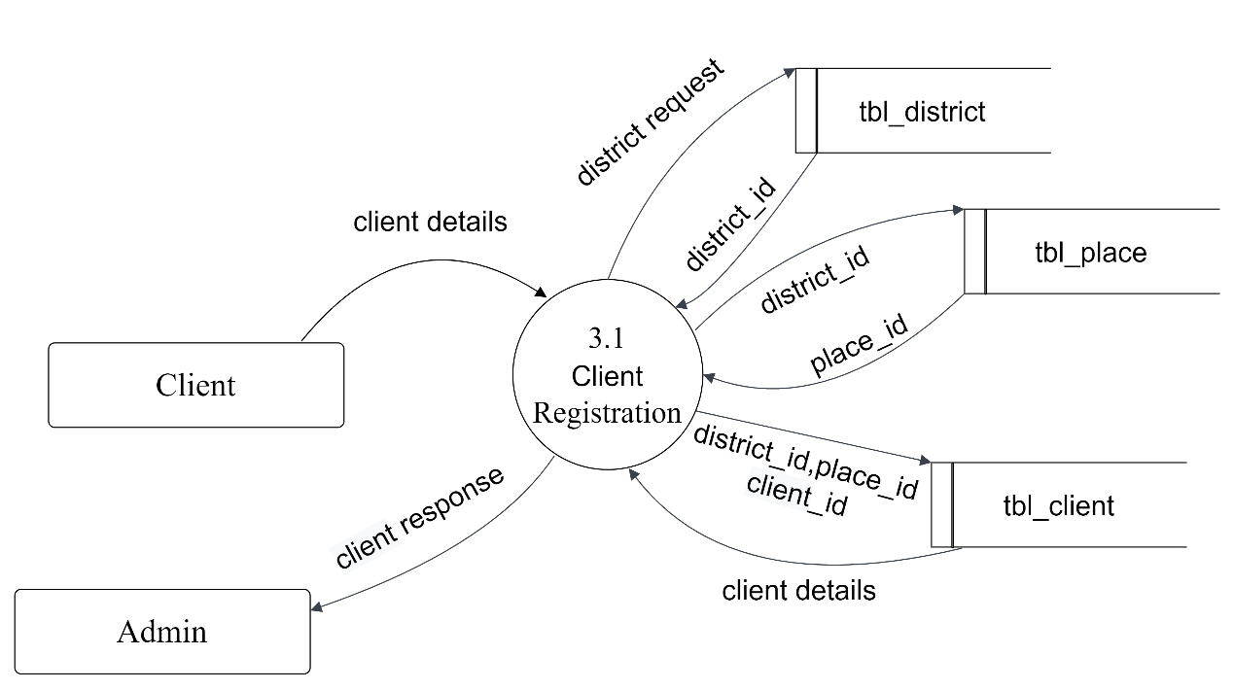

Fig: Second level DFD for Client Registration

**3.2 CONTRACTOR REGISTRATION**

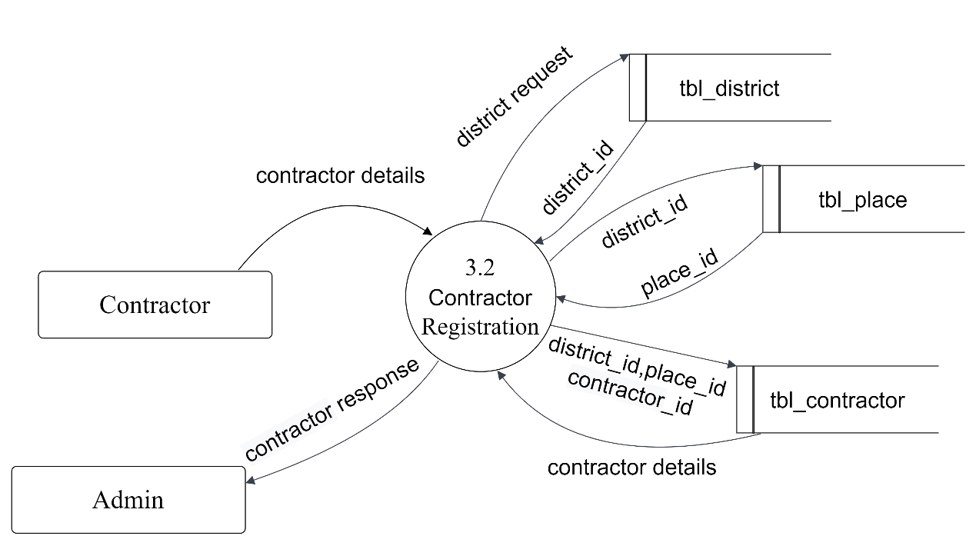

Fig: Second level DFD for Contractor Registration

**3.3 LANDLORD REGISTRATION**

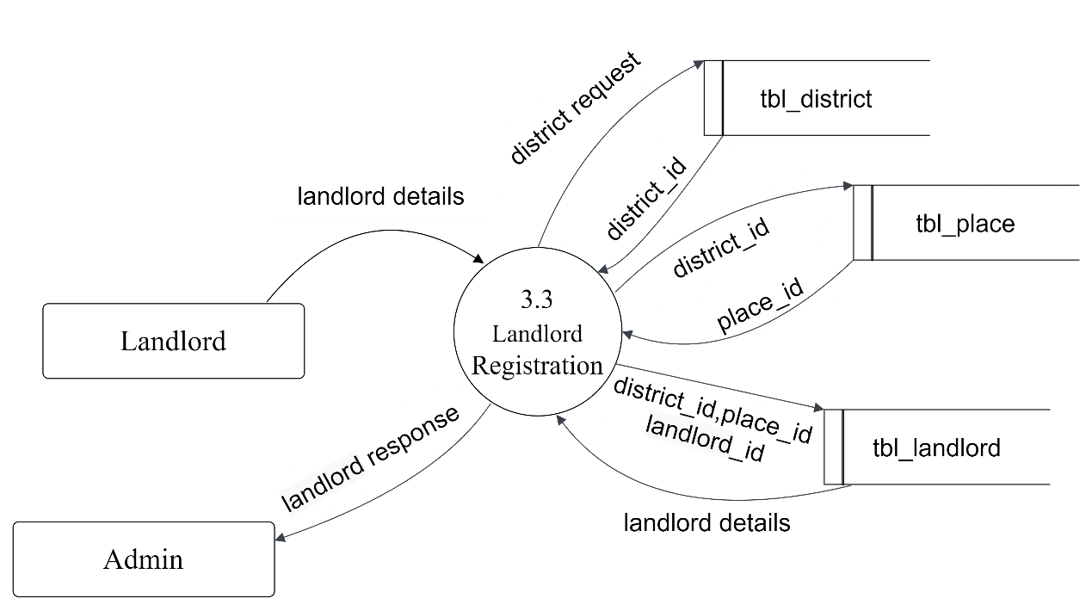Fig: Second level DFD for Landlord Registration

**LEVEL 2 DFD**

**4.1 WORK REGISTRATION**

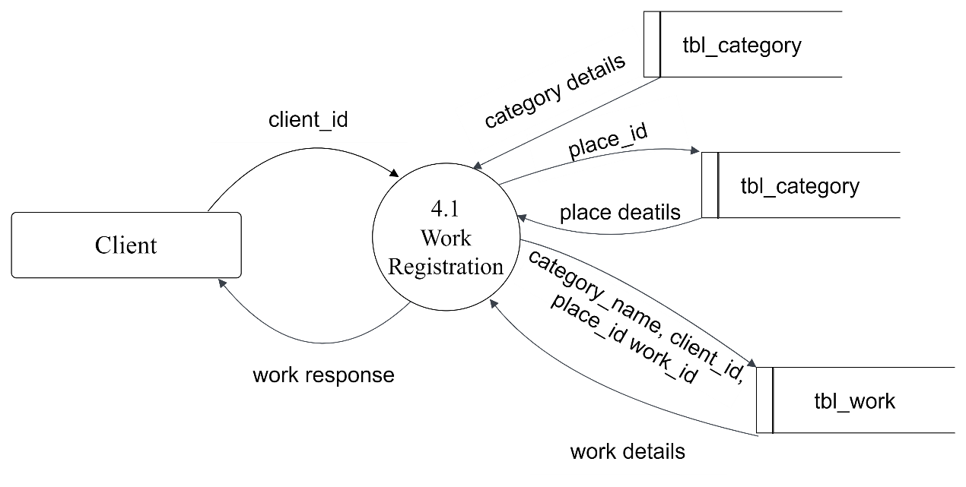

Fig: Second level DFD for Work Registration

**4.2 WORK REQUEST**

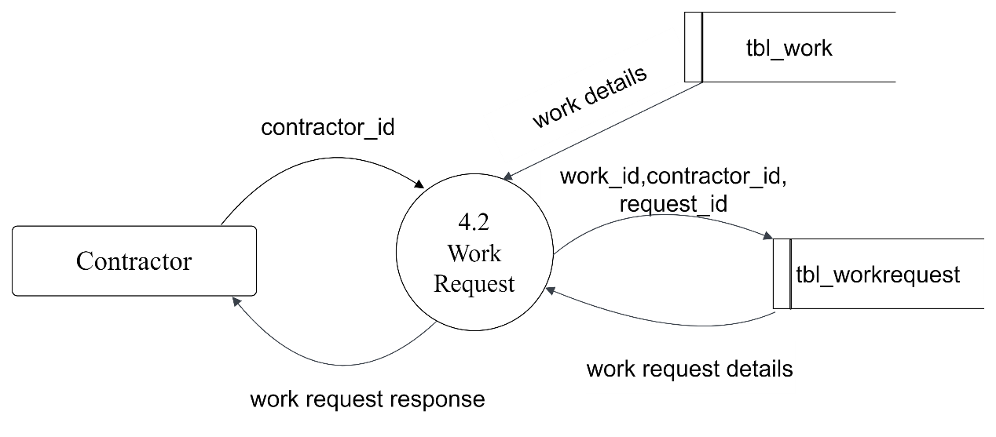

Fig: Second level DFD for Work Request

**4.3 WORK REQUEST APPROVAL**

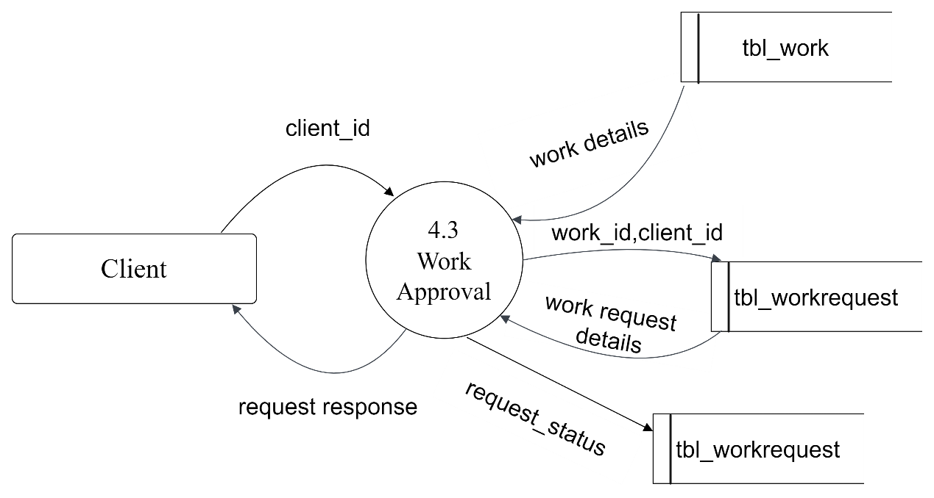

Fig: Second level DFD for Work Request Approval

**4.4 CLIENT CHAT**

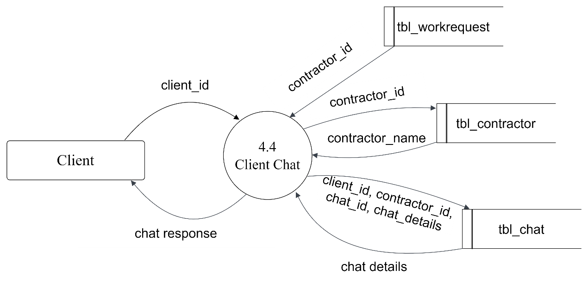

Fig: Second level DFD for Client Chat

**4.5 CONTRACTOR CHAT**

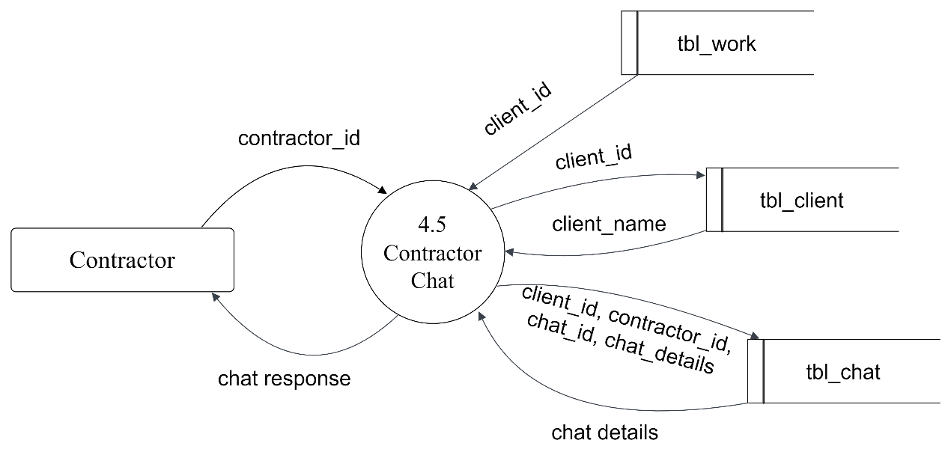

Fig: Second level DFD for Contractor Chat

**LEVEL 2 DFD**

**5.1 PLOT REGISTRATION**

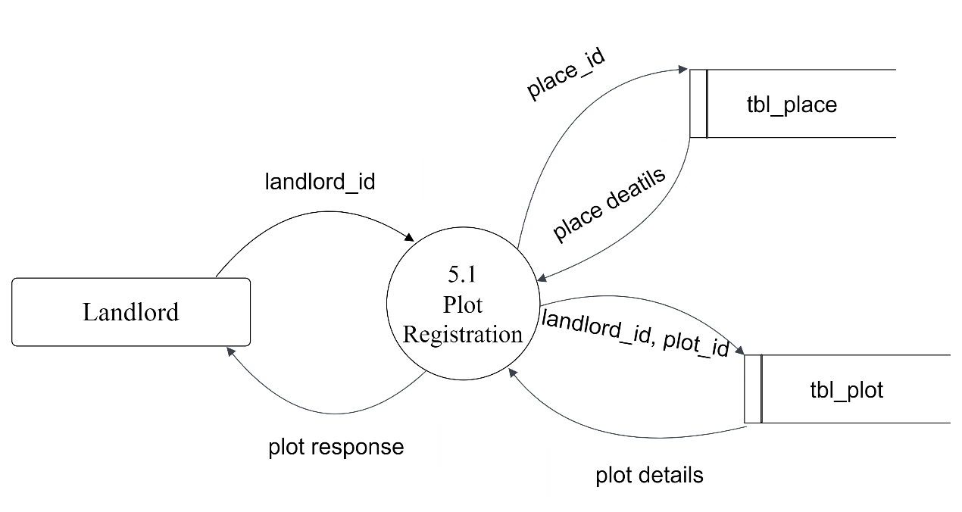

Fig: Second level DFD for Plot Registration

**5.2 PLOT BOOKING**

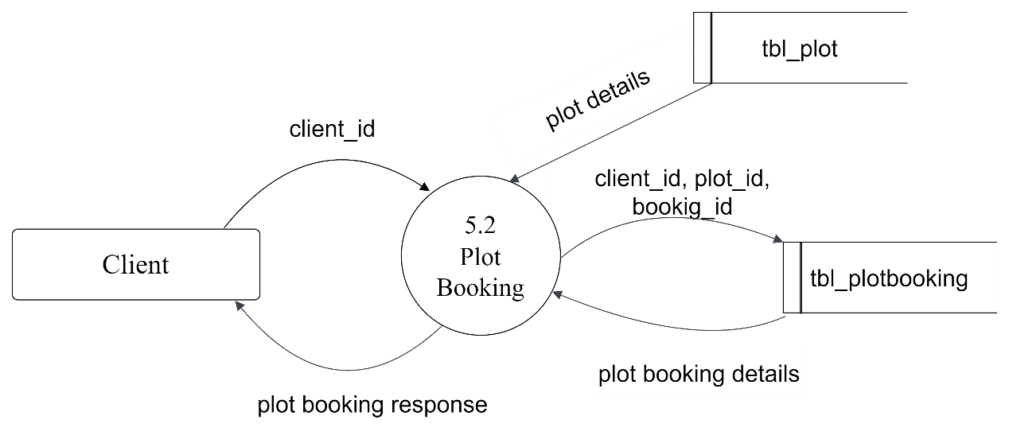

Fig: Second level DFD for Plot Booking

**LEVEL 2 DFD**

**6.1 CLIENT REPORT**

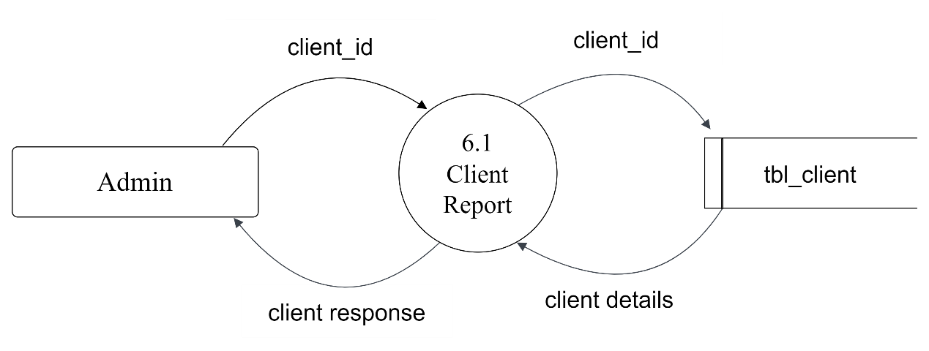

Fig: Second level DFD for Client Report

**6.2 CONTRACTOR REPORT**

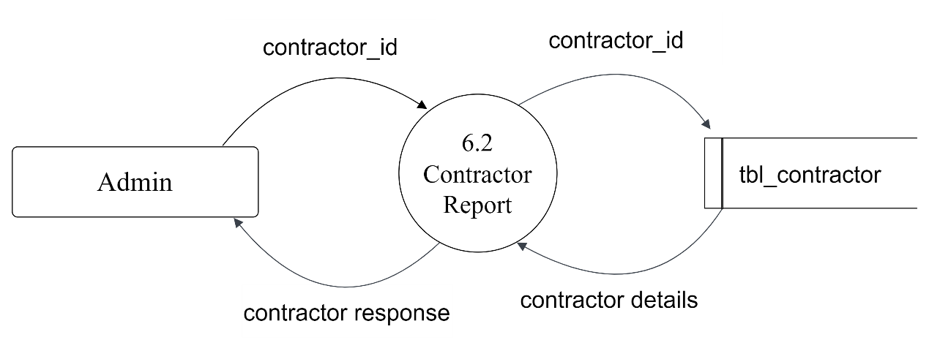

Fig: Second level DFD for Contractor Report

**6.3 LANDLORD REPORT**

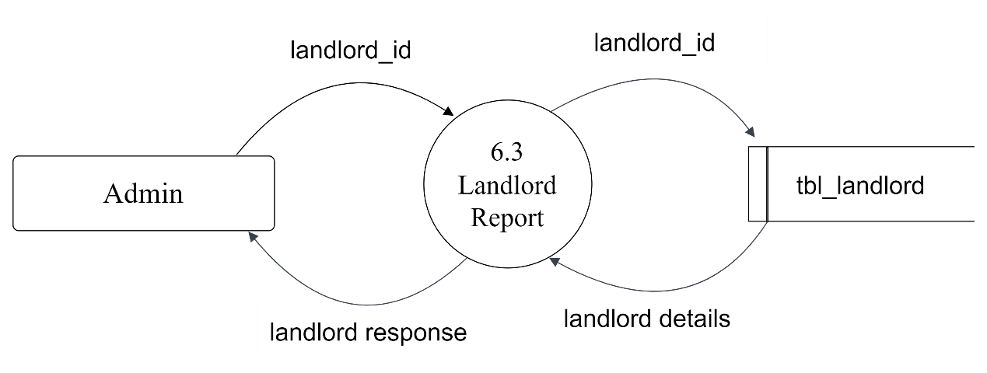

Fig: Second level DFD for Landlord Report

**6.4 COMPLAINT REPORT**

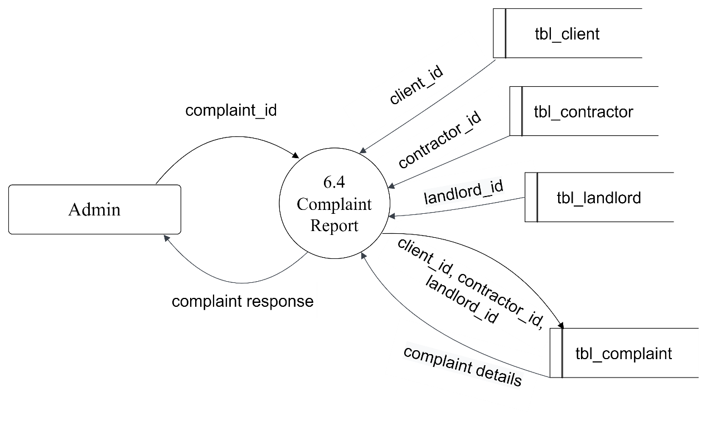

Fig: Second level DFD for Complaint Report

**6.5 FEEDBACK REPORT**

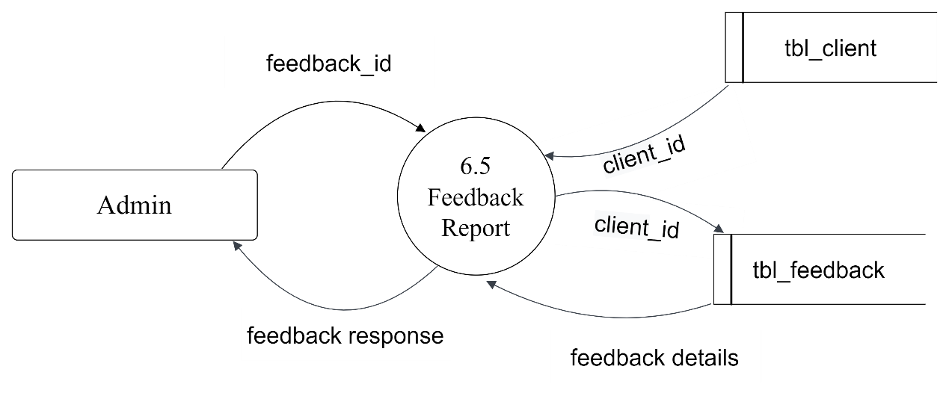

Fig: Second level DFD for Feedback Report

**6. TABLE DESIGN**

**6. TABLE DESIGN**

What is Database Design?

Designing a proper database reduces the maintenance cost thereby improving data consistency and the cost-effective measures are greatly influenced in terms of disk storage space. Therefore, there has to be a brilliant concept of designing a database. The designer should follow the constraints and decide how the elements correlate and what kind of data must be stored. The main objectives behind database designing are to produce physical and logical design models of the proposed database system. To elaborate this, the logical model is primarily concentrated on the requirements of data and the considerations must be made in terms of monolithic considerations and hence the stored physical data must be stored independent of the physical conditions. On the other hand, the physical database design model includes a translation of the logical design model of the database by keep control of physical media using hardware resources and software systems such as Database Management System (DBMS).

There are mainly 14 tables used in this project. They are,

1. tbl_admin
2. tbl_category
3. tbl_district
4. tbl_place
5. tbl_client
6. tbl_contractor
7. tbl_landlord
8. tbl_plot
9. tbl_plotbooking
10. tbl_work
11. tbl_workrequest tbl_chat
12. tbl_chat
13. tbl_complaint
14. tbl_feedback

**1. Table: tbl_admin**

Description: The table contains the details of admin login.

Primary Key: admin_id

Foreign Key: null

|  |  |  |  |
| --- | --- | --- | --- |
| **Field Name** | **Data Type** | **Constraints** | **Description** |
| admin_id | int(11) | PRIMARY KEY | Id of Admin |
| admin_name | varchar(20) | NOT NULL | Admin Username |
| admin_email | varchar(50) | UNIQUE | Admin email for login |
| admin_password | varchar(30) | NOT NULL | Password used by admin for login |

**2. Table: tbl_category**

Description: The table contains the details of work categories.

Primary Key: category_id

Foreign Key: null

|  |  |  |  |
| --- | --- | --- | --- |
| **Field Name** | **Data Type** | **Constraints** | **Description** |
| category_id | Int | PRIMARY KEY | Id of Category |
| category_name | Varchar | NOT NULL | Work category |

**3. Table: tbl_district**

Description: The table contains the details of districts.

Primary Key: district_id

Foreign Key: null

|  |  |  |  |
| --- | --- | --- | --- |
| **Field Name** | **Data Type** | **Constraints** | **Description** |
| district_id | int(11) | PRIMARY KEY | Unique id of district |
| district_name | varchar(50) | NOT NULL | Name of districts |

**4. Table: tbl_place**

Description: The table contains the name of places in each district.

Primary Key: place_id

Foreign Key: district_id

|  |  |  |  |
| --- | --- | --- | --- |
| **Field Name** | **Data Type** | **Constraints** | **Description** |
| place_id | int(11) | PRIMARY KEY | Unique id of each place |
| place_name | varchar(50) | NOT NULL | Name of palce |
| district_id | int(11) | FOREIGN KEY | Id of the district to which the place belongs |

**5. Table: tbl_client**

Description: The table contains the details of clients.

Primary Key: client_id

Foreign Key: place_id

|  |  |  |  |
| --- | --- | --- | --- |
| **Field Name** | **Data Type** | **Constraints** | **Description** |
| [client_id](http://localhost/phpmyadmin/index.php?route=/table/structure/change&change_column=1&field=client_id) | Int | PRIMARY KEY | Unique id of each place |
| [client_name](http://localhost/phpmyadmin/index.php?route=/table/structure/change&change_column=1&field=client_name) | Char | NOT NULL | Name of the client |
| [client_email](http://localhost/phpmyadmin/index.php?route=/table/structure/change&change_column=1&field=client_email) | varchar | UNIQUE | Email of the client |
| [client_address](http://localhost/phpmyadmin/index.php?route=/table/structure/change&change_column=1&field=client_address) | Text | NOT NULL | Address of the client |
| [client_gender](http://localhost/phpmyadmin/index.php?route=/table/structure/change&change_column=1&field=client_gender) | varchar | NOT NULL | Gender of client |
| [client_contact](http://localhost/phpmyadmin/index.php?route=/table/structure/change&change_column=1&field=client_contact) | varchar | NOT NULL | Phone number of client |
| [client_photo](http://localhost/phpmyadmin/index.php?route=/table/structure/change&change_column=1&field=client_photo) | varchar | NOT NULL | Photo of client |
| [place_id](http://localhost/phpmyadmin/index.php?route=/table/structure/change&change_column=1&field=place_id) | int | FOREIGN KEY | Id of place |
| [client_password](http://localhost/phpmyadmin/index.php?route=/table/structure/change&change_column=1&field=client_password) | Char | NOT NULL | Password of the client for login |

**6. Table: tbl_contractor**

Description: The table contains the details of contractors.

Primary Key: contractor_id

Foreign Key: place_id

|  |  |  |  |
| --- | --- | --- | --- |
| **Field Name** | **Data Type** | **Constraints** | **Description** |
| [contractor_id](http://localhost/phpmyadmin/index.php?route=/table/structure/change&change_column=1&field=contractor_id) | Int | PRIMARY KEY | Unique id of each contractor |
| [contractor_name](http://localhost/phpmyadmin/index.php?route=/table/structure/change&change_column=1&field=contractor_name) | Char | NOT NULL | Name of the contractor |
| [contractor_email](http://localhost/phpmyadmin/index.php?route=/table/structure/change&change_column=1&field=contractor_email) | Varchar | UNIQUE | Email of the contractor |
| [contractor_contact](http://localhost/phpmyadmin/index.php?route=/table/structure/change&change_column=1&field=contractor_contact) | Varchar | NOT NULL | Phone number of contractor |
| [contractor_address](http://localhost/phpmyadmin/index.php?route=/table/structure/change&change_column=1&field=contractor_address) | Text | NOT NULL | Address of the contractor |
| [contractor_gender](http://localhost/phpmyadmin/index.php?route=/table/structure/change&change_column=1&field=contractor_gender) | Char | NOT NULL | Gender of contractor |
| [contractor_photo](http://localhost/phpmyadmin/index.php?route=/table/structure/change&change_column=1&field=contractor_photo) | Varchar | NOT NULL | Photo of contractor |
| [contractor_proof](http://localhost/phpmyadmin/index.php?route=/table/structure/change&change_column=1&field=contractor_proof) | Varchar | FOREIGN KEY | Proof of the contractor |
| [place_id](http://localhost/phpmyadmin/index.php?route=/table/structure/change&change_column=1&field=place_id) | Int | NOT NULL | Id of place |
| [contractor_password](http://localhost/phpmyadmin/index.php?route=/table/structure/change&change_column=1&field=contractor_password) | Varchar | NOT NULL | Password of the contractor for login |
| contractor_status | int |  | Status of the contractor |

**7. Table: tbl_landlord**

Description: The table contains the details of landlords.

Primary Key: landlord_id

Foreign Key: place_id

|  |  |  |  |
| --- | --- | --- | --- |
| **Field Name** | **Data Type** | **Constraints** | **Description** |
| [landlord_id](http://localhost/phpmyadmin/index.php?route=/table/structure/change&change_column=1&field=landlord_id) | Int | PRIMARY KEY | Unique id of each landlord |
| [landlord_name](http://localhost/phpmyadmin/index.php?route=/table/structure/change&change_column=1&field=landlord_name) | Char | NOT NULL | Name of the landlord |
| [landlord_email](http://localhost/phpmyadmin/index.php?route=/table/structure/change&change_column=1&field=landlord_email) | Varchar | UNIQUE | Email of the landlord |
| [landlord_contact](http://localhost/phpmyadmin/index.php?route=/table/structure/change&change_column=1&field=landlord_contact) | Varchar | NOT NULL | Phone number of landlord |
| [landlord_address](http://localhost/phpmyadmin/index.php?route=/table/structure/change&change_column=1&field=landlord_address) | Text | NOT NULL | Address of the landlord |
| [landlord_gender](http://localhost/phpmyadmin/index.php?route=/table/structure/change&change_column=1&field=landlord_gender) | Char | NOT NULL | Gender of landlord |
| [landlord_photo](http://localhost/phpmyadmin/index.php?route=/table/structure/change&change_column=1&field=landlord_photo) | Varchar | NOT NULL | Photo of landlord |
| [landlord_proof](http://localhost/phpmyadmin/index.php?route=/table/structure/change&change_column=1&field=landlord_proof) | Varchar | FOREIGN KEY | Proof of the landlord |
| [landlord_password](http://localhost/phpmyadmin/index.php?route=/table/structure/change&change_column=1&field=landlord_password) | Varchar | NOT NULL | Password of the landlord for login. |
| [place_id](http://localhost/phpmyadmin/index.php?route=/table/structure/change&change_column=1&field=place_id) | Int | NOT NULL | Id of place |
| [landlord_status](http://localhost/phpmyadmin/index.php?route=/table/structure/change&change_column=1&field=landlord_status) | Int |  | Status of the landlord |

**8. Table: tbl_plot**

Description: The table contains the details of plots to be sold.

Primary Key: plot_id

Foreign Key: landlord_id, place_id

|  |  |  |  |
| --- | --- | --- | --- |
| **Field Name** | **Data Type** | **Constraints** | **Description** |
| [plot_id](http://localhost/phpmyadmin/index.php?route=/table/structure/change&change_column=1&field=plot_id) | Int | PRIMARY KEY | Unique id of each plot |
| [landlord_id](http://localhost/phpmyadmin/index.php?route=/table/structure/change&change_column=1&field=landlord_id) | Int | FOREIGN KEY | Id of the land owner |
| [plot_details](http://localhost/phpmyadmin/index.php?route=/table/structure/change&change_column=1&field=plot_details) | Text | NOT NULL | Details about the plot |
| [plot_landmark](http://localhost/phpmyadmin/index.php?route=/table/structure/change&change_column=1&field=plot_landmark) | Varchar | NOT NULL | Landmark of the plot |
| [place_id](http://localhost/phpmyadmin/index.php?route=/table/structure/change&change_column=1&field=place_id) | Int | FOREIGN KEY | Id of the place |
| [advance_amount](http://localhost/phpmyadmin/index.php?route=/table/structure/change&change_column=1&field=advance_amount) | Int | NOT NULL | Advance amount of the plot |
| [plot_status](http://localhost/phpmyadmin/index.php?route=/table/structure/change&change_column=1&field=plot_status) | Int |  | Status of the plot |

**9. Table: tbl_plotbooking**

Description: The table contains the plotbooking details.

Primary Key: booking_id

Foreign Key: client_id, plot_id

|  |  |  |  |
| --- | --- | --- | --- |
| **Field Name** | **Data Type** | **Constraints** | **Description** |
| [booking_id](http://localhost/phpmyadmin/index.php?route=/table/structure/change&change_column=1&field=booking_id) | Int | PRIMARY KEY | Unique id of plot booking |
| [plot_id](http://localhost/phpmyadmin/index.php?route=/table/structure/change&change_column=1&field=plot_id) | Int | FOREIGN KEY | Id of the plot |
| [client_id](http://localhost/phpmyadmin/index.php?route=/table/structure/change&change_column=1&field=client_id) | Int | FOREIGN KEY | Id of client |
| [payment_status](http://localhost/phpmyadmin/index.php?route=/table/structure/change&change_column=1&field=payment_status) | Int |  | Shows status of payment |
| [booking_date](http://localhost/phpmyadmin/index.php?route=/table/structure/change&change_column=1&field=booking_date) | Date | NOT NULL | Date of plotbooking |

**10. Table: tbl_work**

Description: The table contains the details of works to be done.

Primary Key: work_id

Foreign Key: client_id, place_id, [category_id](http://localhost/phpmyadmin/index.php?route=/table/structure/change&change_column=1&field=category_id)

|  |  |  |  |
| --- | --- | --- | --- |
| **Field Name** | **Data Type** | **Constraints** | **Description** |
| [work_id](http://localhost/phpmyadmin/index.php?route=/table/structure/change&change_column=1&field=work_id) | Int | PRIMARY KEY | Unique id of each work |
| [category_id](http://localhost/phpmyadmin/index.php?route=/table/structure/change&change_column=1&field=category_id) | Int | FOREIGN KEY | Shows the category of work |
| [work_details](http://localhost/phpmyadmin/index.php?route=/table/structure/change&change_column=1&field=work_details) | Text | NOT NULL | Details about the work |
| [client_id](http://localhost/phpmyadmin/index.php?route=/table/structure/change&change_column=1&field=client_id) | Int | FOREIGN KEY | Id of the client |
| [work_status](http://localhost/phpmyadmin/index.php?route=/table/structure/change&change_column=1&field=work_status) | Int |  | Status of the work |
| [work_date](http://localhost/phpmyadmin/index.php?route=/table/structure/change&change_column=1&field=work_date) | Date | NOT NULL | Maximum expected date by the client for work completion |
| [place_id](http://localhost/phpmyadmin/index.php?route=/table/structure/change&change_column=1&field=place_id) | Int | FOREIGN KEY | Id of the place |
| [work_photo](http://localhost/phpmyadmin/index.php?route=/table/structure/change&change_column=1&field=work_photo) | Varchar |  | Photo related to the work if any |

**11. Table: tbl_workrequest**

Description: The table contains the details of work requests to the client.

Primary Key: request_id

Foreign Key: contractor_id, work_id

|  |  |  |  |
| --- | --- | --- | --- |
| **Field Name** | **Data Type** | **Constraints** | **Description** |
| [request_id](http://localhost/phpmyadmin/index.php?route=/table/structure/change&change_column=1&field=request_id) | Int | PRIMARY KEY | Unique id of each work request |
| [request_details](http://localhost/phpmyadmin/index.php?route=/table/structure/change&change_column=1&field=request_details) | Text | NOT NULL | Shows the request details |
| [work_id](http://localhost/phpmyadmin/index.php?route=/table/structure/change&change_column=1&field=work_id) | Int | FOREIGN KEY | Id of each work |
| [contractor_id](http://localhost/phpmyadmin/index.php?route=/table/structure/change&change_column=1&field=contractor_id) | Int | FOREIGN KEY | Id of the contractor |
| [request_status](http://localhost/phpmyadmin/index.php?route=/table/structure/change&change_column=1&field=request_status) | Int |  | Status of the request |
| [request_date](http://localhost/phpmyadmin/index.php?route=/table/structure/change&change_column=1&field=request_date) | Date | NOT NULL | Maximum estimated date by the contractor for work completion |

**12. Table: tbl_chat**

Description: The table contains the chat details.

Primary Key: chat_id

Foreign Key: client_id, contractor_id

|  |  |  |  |
| --- | --- | --- | --- |
| **Field Name** | **Data Type** | **Constraints** | **Description** |
| [chat_id](http://localhost/phpmyadmin/index.php?route=/table/structure/change&change_column=1&field=chat_id) | Int | PRIMARY KEY | Unique id of each plot |
| [chat_fromcon](http://localhost/phpmyadmin/index.php?route=/table/structure/change&change_column=1&field=chat_fromcon) | Int | FOREIGN KEY | Id of the contractor |
| [chat_tocon](http://localhost/phpmyadmin/index.php?route=/table/structure/change&change_column=1&field=chat_tocon) | Int | FOREIGN KEY | Id of the contractor |
| [chat_fromclient](http://localhost/phpmyadmin/index.php?route=/table/structure/change&change_column=1&field=chat_fromclient) | Int | FOREIGN KEY | Id of the client |
| [chat_toclient](http://localhost/phpmyadmin/index.php?route=/table/structure/change&change_column=1&field=chat_toclient) | Int | FOREIGN KEY | Id of the client |
| [chat_content](http://localhost/phpmyadmin/index.php?route=/table/structure/change&change_column=1&field=chat_content) | Varchar | NOT NULL | Chat content |
| [chat_date](http://localhost/phpmyadmin/index.php?route=/table/structure/change&change_column=1&field=chat_date) | Varchar | NOT NULL | Date and time of chat |
| [chat_status](http://localhost/phpmyadmin/index.php?route=/table/structure/change&change_column=1&field=chat_status) | Int |  | Status of the chat |

**13. Table: tbl_complaint**

Description: The table contains the complaints.

Primary Key: complaint_id

Foreign Key: client_id, contractor_id, landlord_id

|  |  |  |  |
| --- | --- | --- | --- |
| **Field Name** | **Data Type** | **Constraints** | **Description** |
| [complaint_id](http://localhost/phpmyadmin/index.php?route=/table/structure/change&change_column=1&field=complaint_id) | Int | PRIMARY KEY | Unique id of each complaint |
| [complaint_title](http://localhost/phpmyadmin/index.php?route=/table/structure/change&change_column=1&field=complaint_title) | Text | NOT NULL | Title for the complaint |
| [complaint_description](http://localhost/phpmyadmin/index.php?route=/table/structure/change&change_column=1&field=complaint_description) | Text | NOT NULL | Complaint description |
| [complaint_status](http://localhost/phpmyadmin/index.php?route=/table/structure/change&change_column=1&field=complaint_status) | Int |  | Id of the client |
| [complaint_date](http://localhost/phpmyadmin/index.php?route=/table/structure/change&change_column=1&field=complaint_date) | Date | NOT NULL | Status of complaint |
| [client_id](http://localhost/phpmyadmin/index.php?route=/table/structure/change&change_column=1&field=client_id) | Int | FOREIGN KEY | Id of the client |
| [contractor_id](http://localhost/phpmyadmin/index.php?route=/table/structure/change&change_column=1&field=contractor_id) | Int | FOREIGN KEY | Id of the contractor |
| [landlord_id](http://localhost/phpmyadmin/index.php?route=/table/structure/change&change_column=1&field=landlord_id) | Int | FOREIGN KEY | Id of the landlord |
| [complaint_reply](http://localhost/phpmyadmin/index.php?route=/table/structure/change&change_column=1&field=complaint_reply) | Text | NOT NULL | Reply given by admin |

**14. Table: tbl_feedback**

Description: The table contains the feedbacks.

Primary Key: feedback_id

Foreign Key: client_id

|  |  |  |  |
| --- | --- | --- | --- |
| **Field Name** | **Data Type** | **Constraints** | **Description** |
| [feedback_id](http://localhost/phpmyadmin/index.php?route=/table/structure/change&change_column=1&field=feedback_id) | Int | PRIMARY KEY | Unique id of each feedback |
| [feedback_content](http://localhost/phpmyadmin/index.php?route=/table/structure/change&change_column=1&field=feedback_content) | varchar | NOT NULL | Feedback description |
| [client_id](http://localhost/phpmyadmin/index.php?route=/table/structure/change&change_column=1&field=client_id) | Int | FOREIGN KEY | Client id |

**7. SYSTEM DESIGN**

**7. SYSTEM DESIGN**

A system architecture or system’s architecture is the conceptual model that defines the structure, behaviour, and more views of a system. An architecture description is a formal description and representation of a system, organized in a way that supports reasoning about the structures of the system, System architecture can comprise system components. The externally visible properties of those components, the relationships (e.g., the behaviour) between them. It can provide a plan from which products can be procured. And systems developed, that will work together to implement the overall system. There have been efforts to formalize languages to describe system architecture; collectively these are called architecture description languages (ADLs).

The system architecture can best be thought of as a set of representations of an existing (or to be created) system. It is used to convey the informational content of the elements comprising a system, the relationships among those elements, and the rules governing those relationships. The architectural components and set of relationships between these components that architecture describes may consist of hardware, software, documentation, facilities, manual procedures, or roles played by organizations or people. System architecture is primarily concerned with the internal interfaces among the system’s components or subsystems, and the interface between the system and its external environment, especially the user. The structural design reduces complexity, facilitates change and results in easier implementation by encouraging parallel development of different parts of the system. The procedural design transforms structural elements of program architecture into a procedural description of software components.

Architectural design considers architecture as the most important functional requirement. The system is based on the three-tier architecture. The first level is the user interface (presentation logic), which displays controls, receives and validates user input. The second level is the business layer (business logic) where the application-specific logic takes place. The third level is the data layer where the application information is stored in files or databases. It contains logic about retrieving and updating data.

**7.1 Input Design**

The input design is the link between the information system and the user. It comprises the developing specification and procedures for data preparation and those steps are necessary to put transaction data into a usable form for processing data entry. The activity of putting data into the computer for processing can be achieved by inspecting the computer to read the data from a written or printed document or it can occur by having people keying the data directly into the system. The design of input focuses on controlling the amount of input required, controlling errors, avoiding delay, avoiding extra steps and keeping the process simple.

The system needs data regarding the asset items, depreciation rates, asset transfer and physical verification for various validation, checking, calculation and report generation. The error-raising method is also included in the software, which helps to raise error messages when the wrong entry of input is done. So, in input design, the following things are considered.

* What data should be considered as input?
* How the data should be arranged or coded?
* Methods for preparing input validations and steps to follow when errors occur.

**7.2 Output Design**

Computer output is the most important and direct information source for the user. Output design is a process that involves designing necessary outputs in the form of reports that should be given to the users according to the requirements. Efficient, intelligible output design should improve the system’s relationship with the user and help in decision-making. Since the reports are directly referred by the management for taking decisions and drawing conclusions, they must be designed with almost care and the details in the reports must be simple, descriptive and clear to the user. So, while designing output the following things are to be considered.

* Determine what information to present.
* Arrange the presentation of information in an acceptable format.
* Decide how to distribute the output to intended receipts.

**8. SYSTEM TESTING AND IMPLEMENTATION**

**8. SYSTEM TESTING AND IMPLEMENTATION**

The objective of system testing is to ensure that all individual programs are working as expected, that the programs link together to meet the requirements specified and to ensure that the computer system and the associated clerical and other procedures work together. The initial phase of system testing is the responsibility of the analyst who determines what conditions are to be tested, generates test data, produced a schedule of expected results, runs the tests and compares the computer produced results with the expected results with expected results. The analyst may also be involved in procedure testing. When the analyst is satisfied that the system is working properly, he hands it over to the users for testing. The importance of system testing by the user who must be stressed. Ultimately it is the user must verify the system and give the go-ahead. During testing, the system is used experimentally to ensure that the software does not fail, i.e., that it will run according to its specifications and in the way. Users expect it to. Special test data is input for processing (test plan) and the results are examined to locate unexpected results. A limited number of users may also be allowed to use the system so analysts can see whether they try to use it in unexpected ways. It is preferable to find these surprises before the organization implements the system and depends on it. In many organizations, testing is performed by persons other than those who write the original programs. Using persons who do not know how certain parts were designed or programmed ensures more complete and unbiased testing and more reliable software.

Parallel running is often regarded as the final phase of system testing. Since the parallel operation of two systems is very demanding in terms of user resources it should be embarked on only if the user is satisfied with the results of testing - - it should not be started if problems are known to exist. Testing is the major quality control measure during software development. Its basic function is to detect errors in the software. Thus, the goal of testing is to uncover requirement design and coding errors in the program. Testing is the process of correcting a program with intend of finding an error.

Different types of testing are:

1. Unit Testing
2. Integration Testing
3. Validation Testing
4. Implementation

**8.1 Unit Testing**

Unit Testing is a software testing technique by means of which individual units of software i.e. group of computer program modules, usage procedures and operating procedures are tested to determine whether they are suitable for use or not. It is a testing method using which every independent module are tested to determine if there is any issue by the developer himself. Unit Testing is defined as a type of software testing where individual components of software are tested. An individual component may be either an individual function or a procedure. Unit Testing is typically performed by the developer.

**8.2 Integration Testing**

In this testing, two or more modules which are unit tested are integrated to test i.e. technique interacting components and are then verified if these integrated modules work as per the expectation or not and interface errors are also detected. The purpose of the integration testing is to expose faults in the interaction between integrated units. Once all the modules have been unit tested, integration testing is performed.

**8.3 Validation Testing**

The process of evaluating software during the development process or at the end of the development process to determine whether it satisfies specified business requirements. Validation Testing ensures that the product actually meets the client's needs. It can also be defined as demonstrating that the product fulfils its intended use when deployed in

an appropriate environment.

**8.4 Implementation**

Implementation is an activity that is contained throughout the development phase. It is a process of bringing a developed system into operational use and turning it over to the user. The new system and its components are to be tested in a structured and planned manner. A successful system should be delivered and users should have confidence that the system would work effectively and efficiently. The more complex the system being implemented the more involved will be the system analysis and design effort required for implementation. System implementation projects are long difficult journeys by which organizations move from an old set of technology/methods/procedures to a new one. A software implementation method is a systematic structured approach to effectively integrate software-based services or components into the workflow of an organizational structure or an individual end-user.

**9. MAINTENANCE**

**9. MAINTENANCE**

Maintenance involves the software industry captive, typing of the system resources it means restoring something to its original condition. Maintenance involves a wide range of activities including correcting, coding, and design errors, updating the documentation and test data and upgrading user support. Maintenance is continued till the product is re-engineered or deployed to another platform. Maintenance is also done based on fixing the problems reported, changing the interface with other software or hardware enhancing the software.

**10. CONCLUSION**

**10. CONCLUSION**

The system titled "Contracto" automates almost all the functionalities related to construction works and real estate management. It overcomes the drawbacks of the existing system. The major benefit is it improved transparency in pricing and scope of work.

The website was developed using MySQL and JSP as the backend and HTML5, CSS 3.0, and JAVASCRIPT as the front end. Android was used for developing mobile application.

The existing system does everything manually which makes the work more complicated. This system makes it easier for all the users associated with the construction and real estate field. It saves the time and efforts of people efficiently. The successful completion of the

system results in:

* Fast data processing
* User-friendliness
* Generation of reports in neat format

**11. BIBLIOGRAPHY**

**11. BIBLIOGRAPHY**

|  |  |
| --- | --- |
| Netbeans IDE | - Apache Software Foundation |
| Android Studio | - Google, JetBrains |
| Google Chrome | - Google |
| Microsoft Edge | - Microsoft |

**12. REFERENCES**

**12. REFERENCES**

1. <https://www.youtube.com/>
2. <https://www.wikipedia.org/>
3. <https://www.w3schools.com/>
4. <https://www.javatpoint.com/>
5. <https://stackoverflow.com/>
6. <https://www.wampserver.com/>
7. <https://developer.android.com/>
8. <https://getbootstrap.com/>
9. https://netbeans.apache.org/

**13. SCREENSHOTS**

**13. SCREENSHOTS**

**Login page**

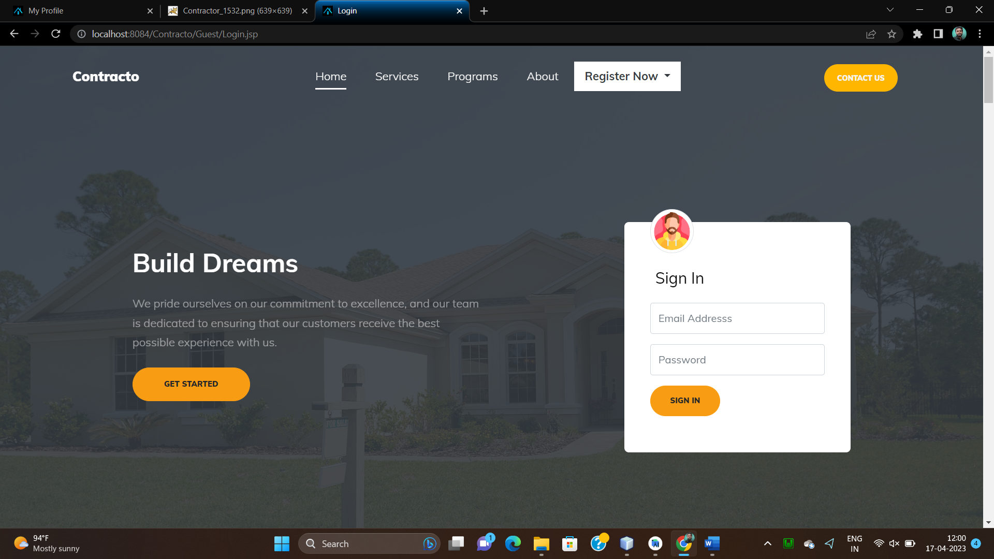

**Client Registration**

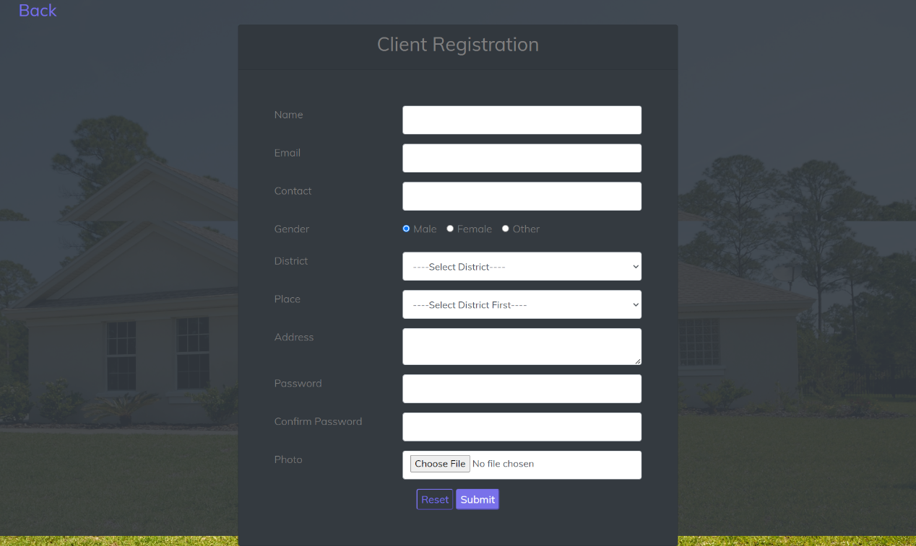

**Contractor Registration**

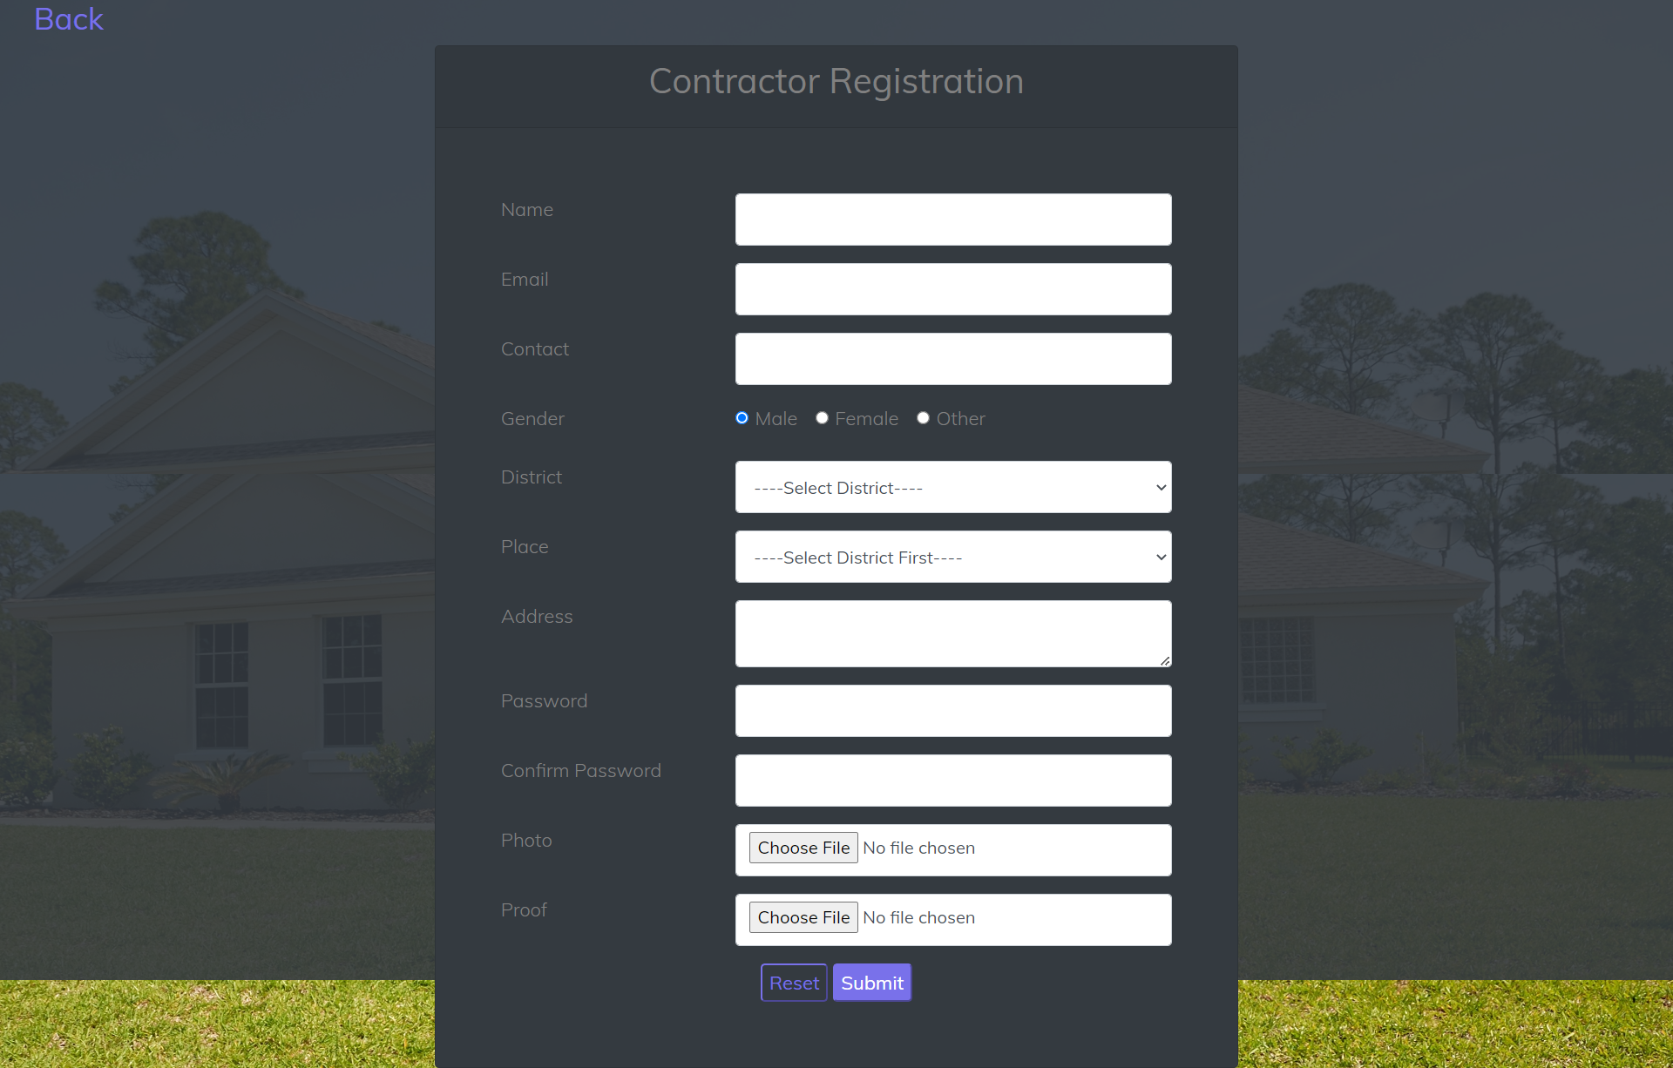

**Landlord Registration**

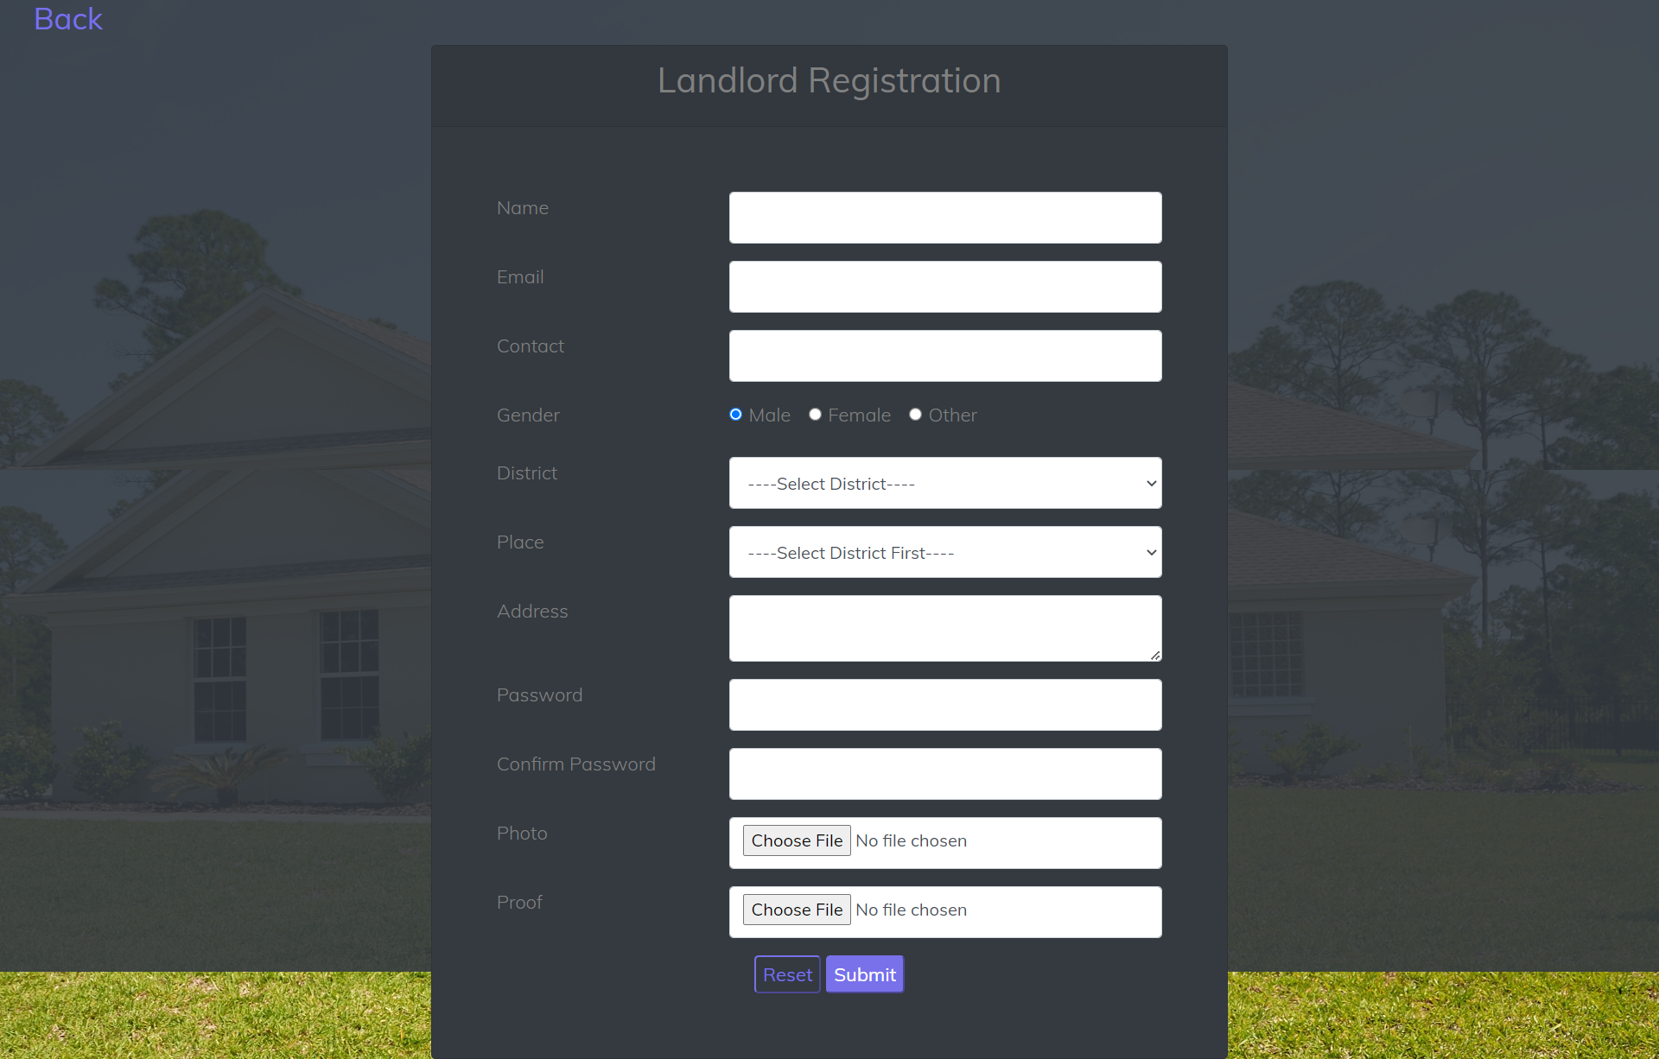

**Admin Dashboard**

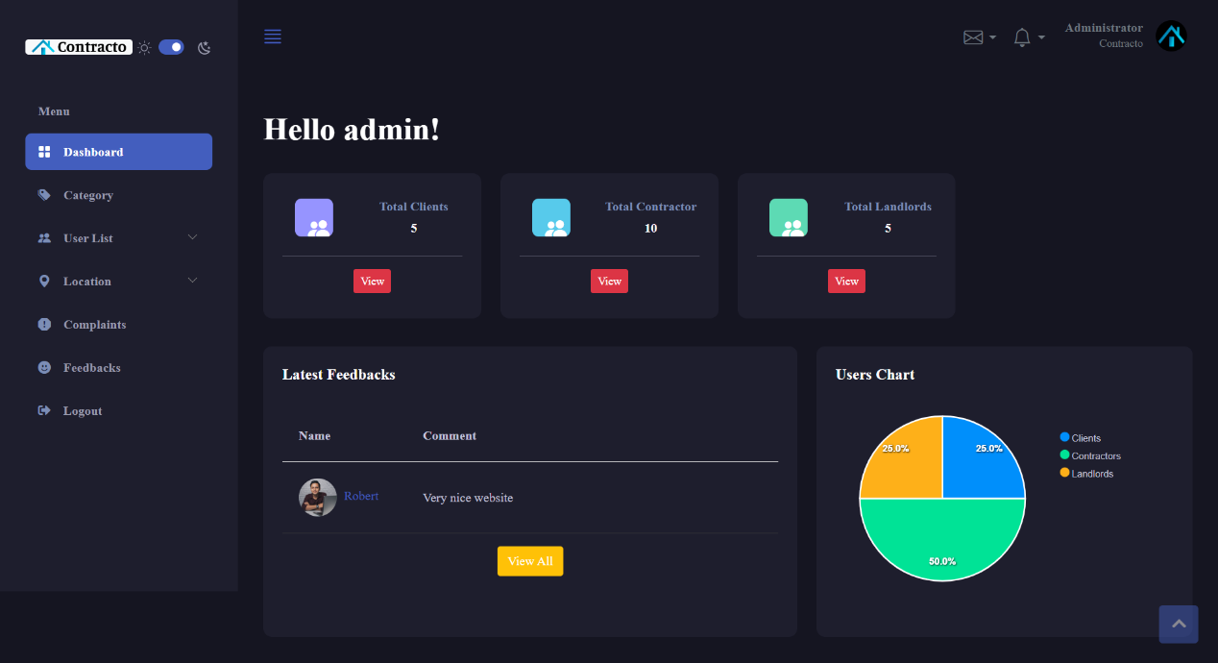

**Category Registration**

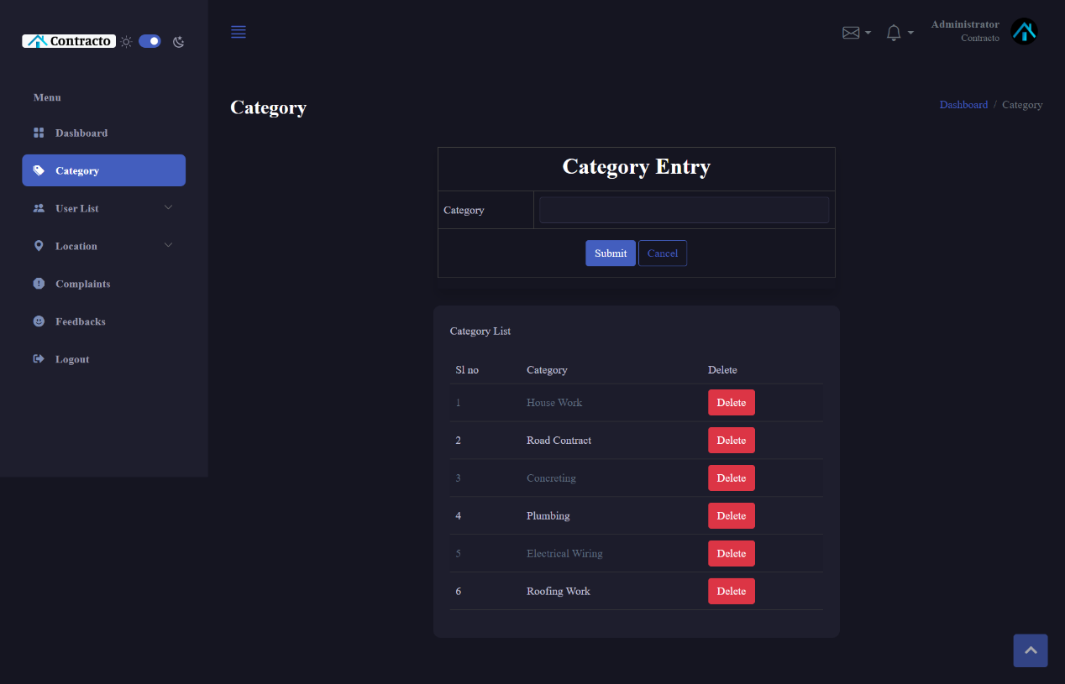

**Client List**

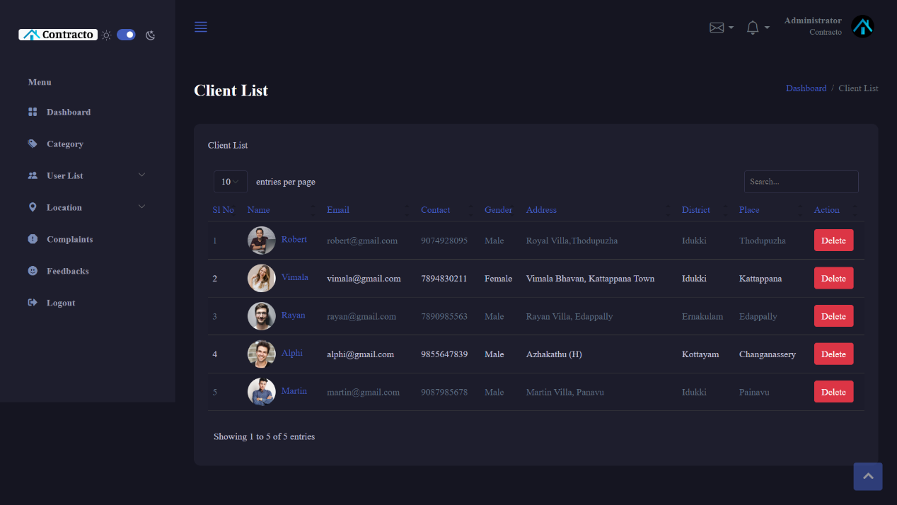

**Contractor List**

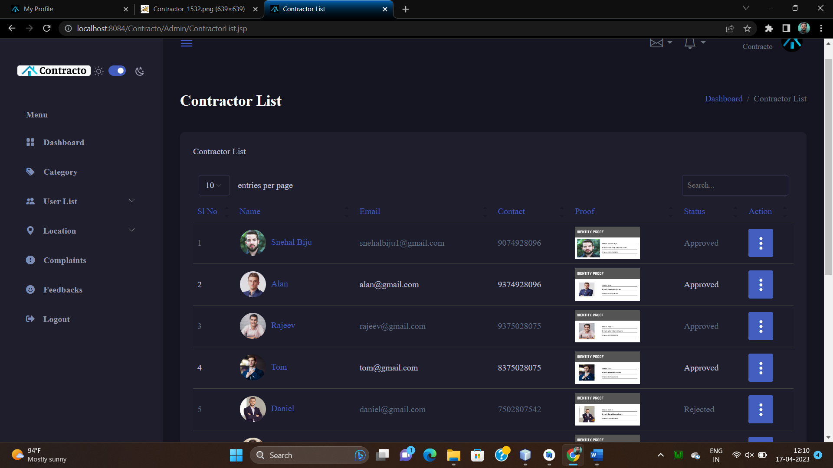

**Landlord List**

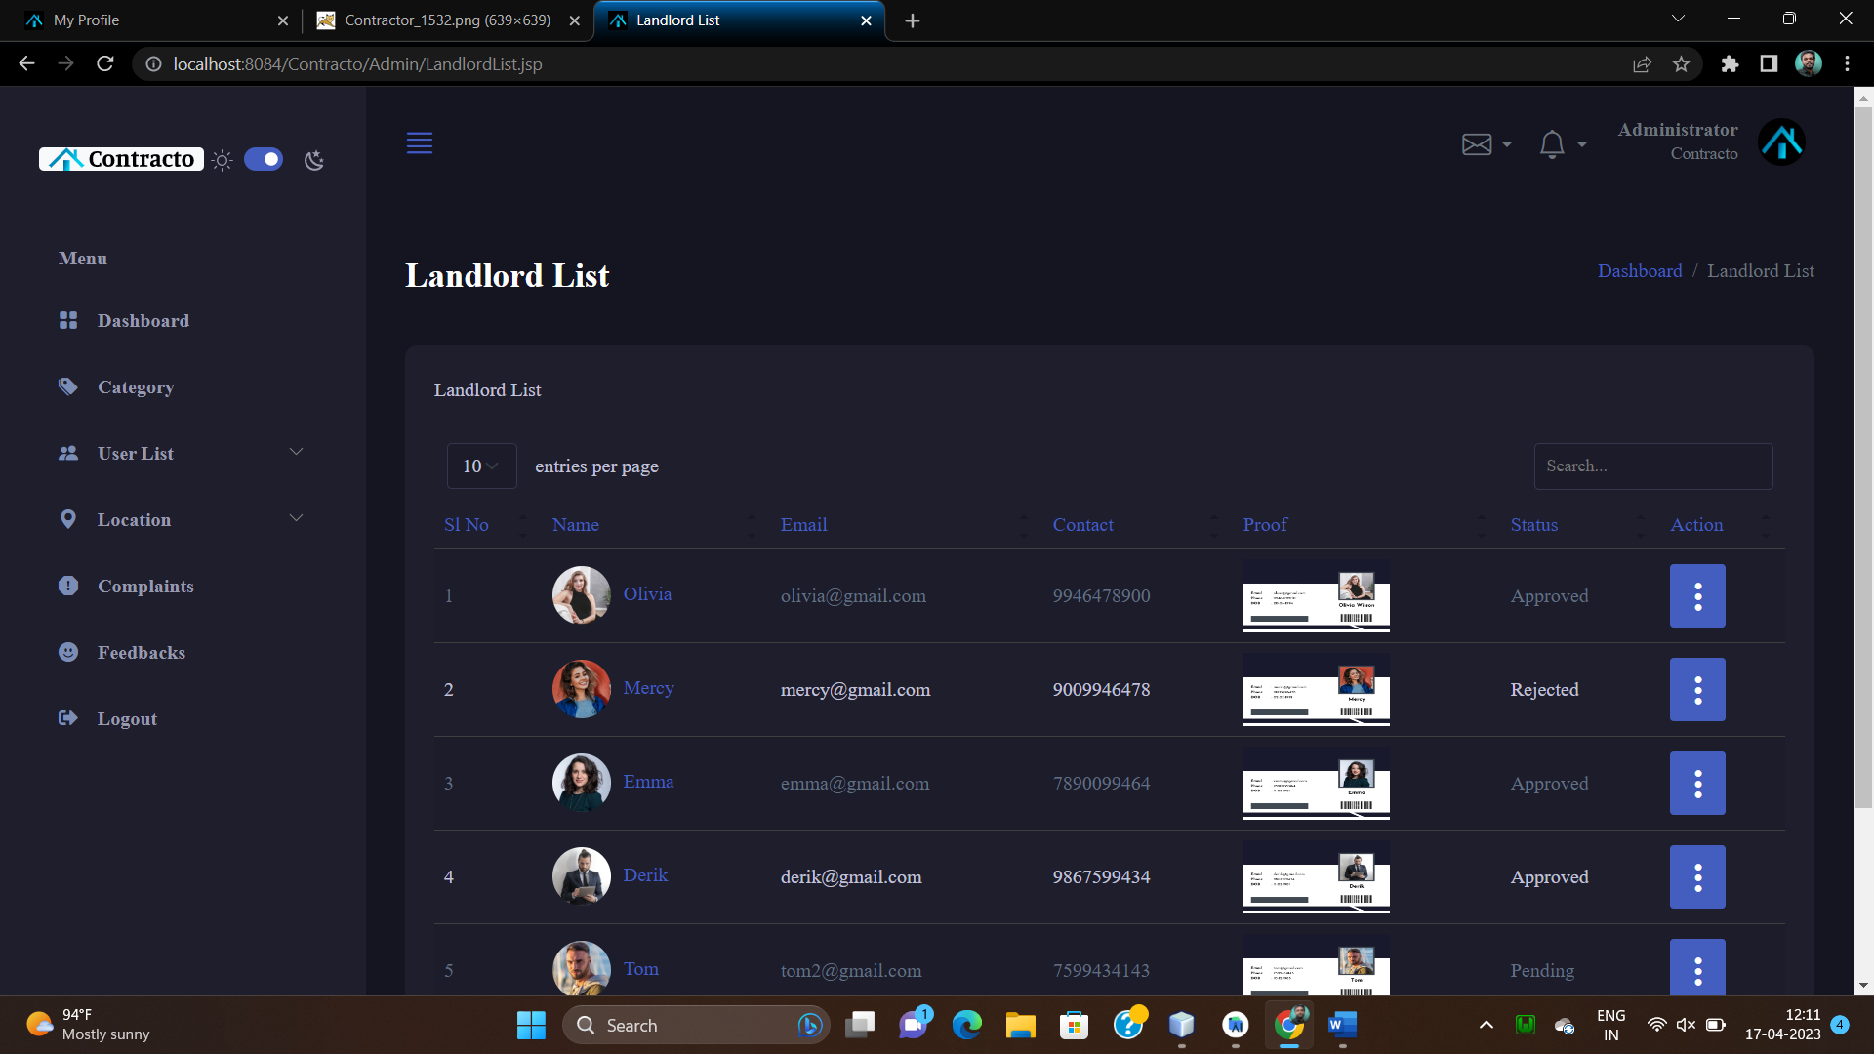

**District Registration**

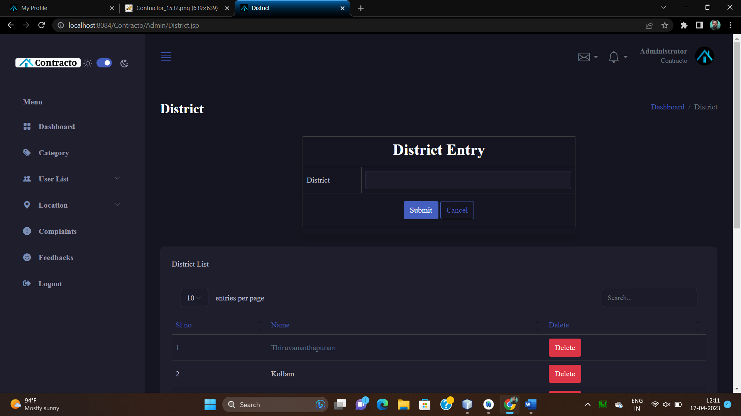

**Place registration**

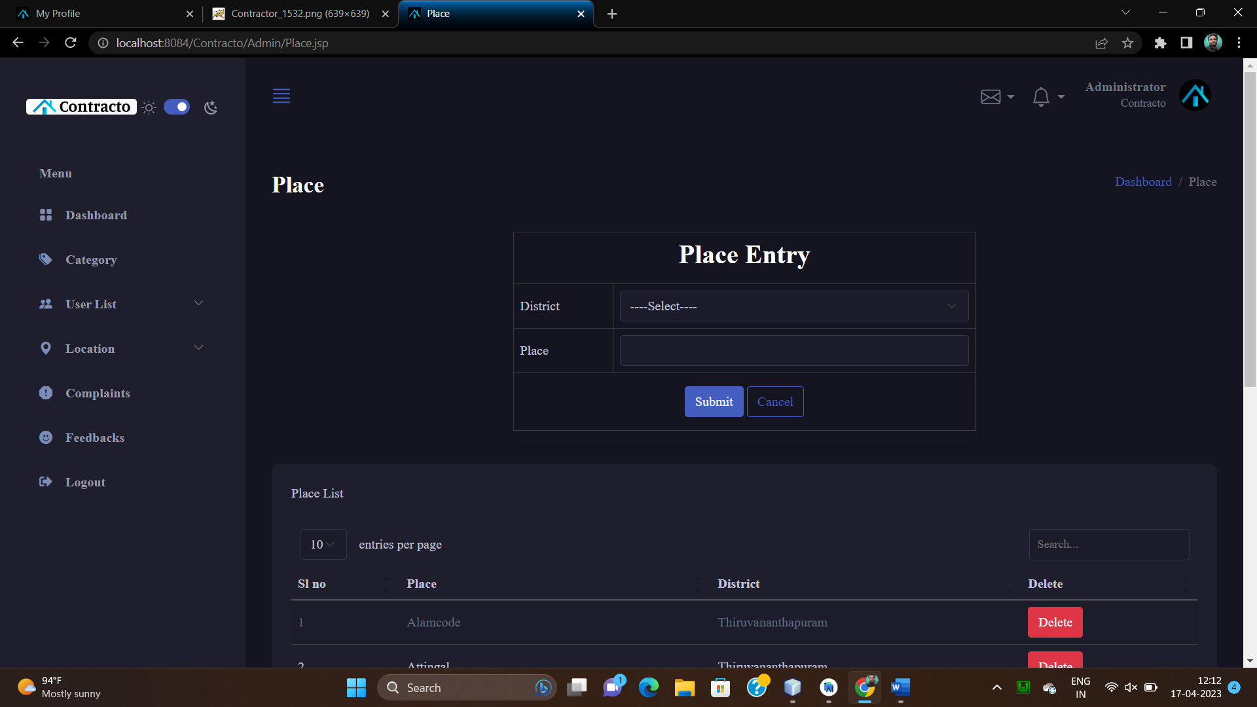

**Complaint View**

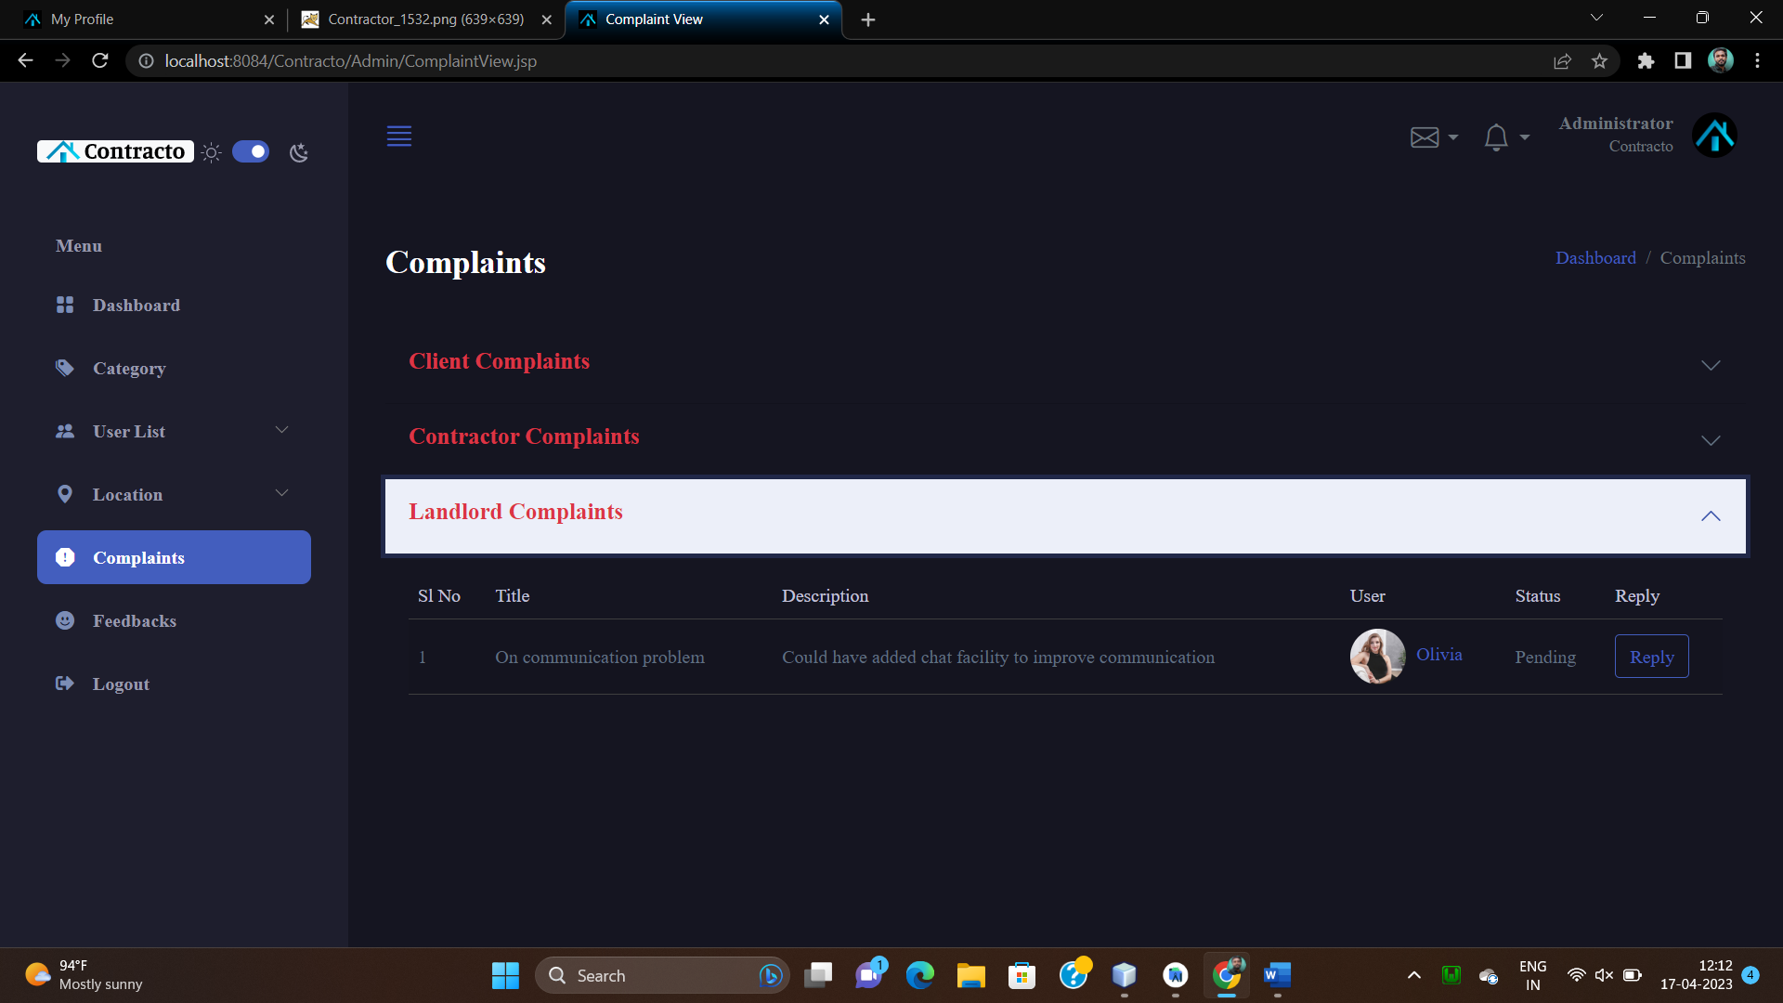

**Complaint Reply**

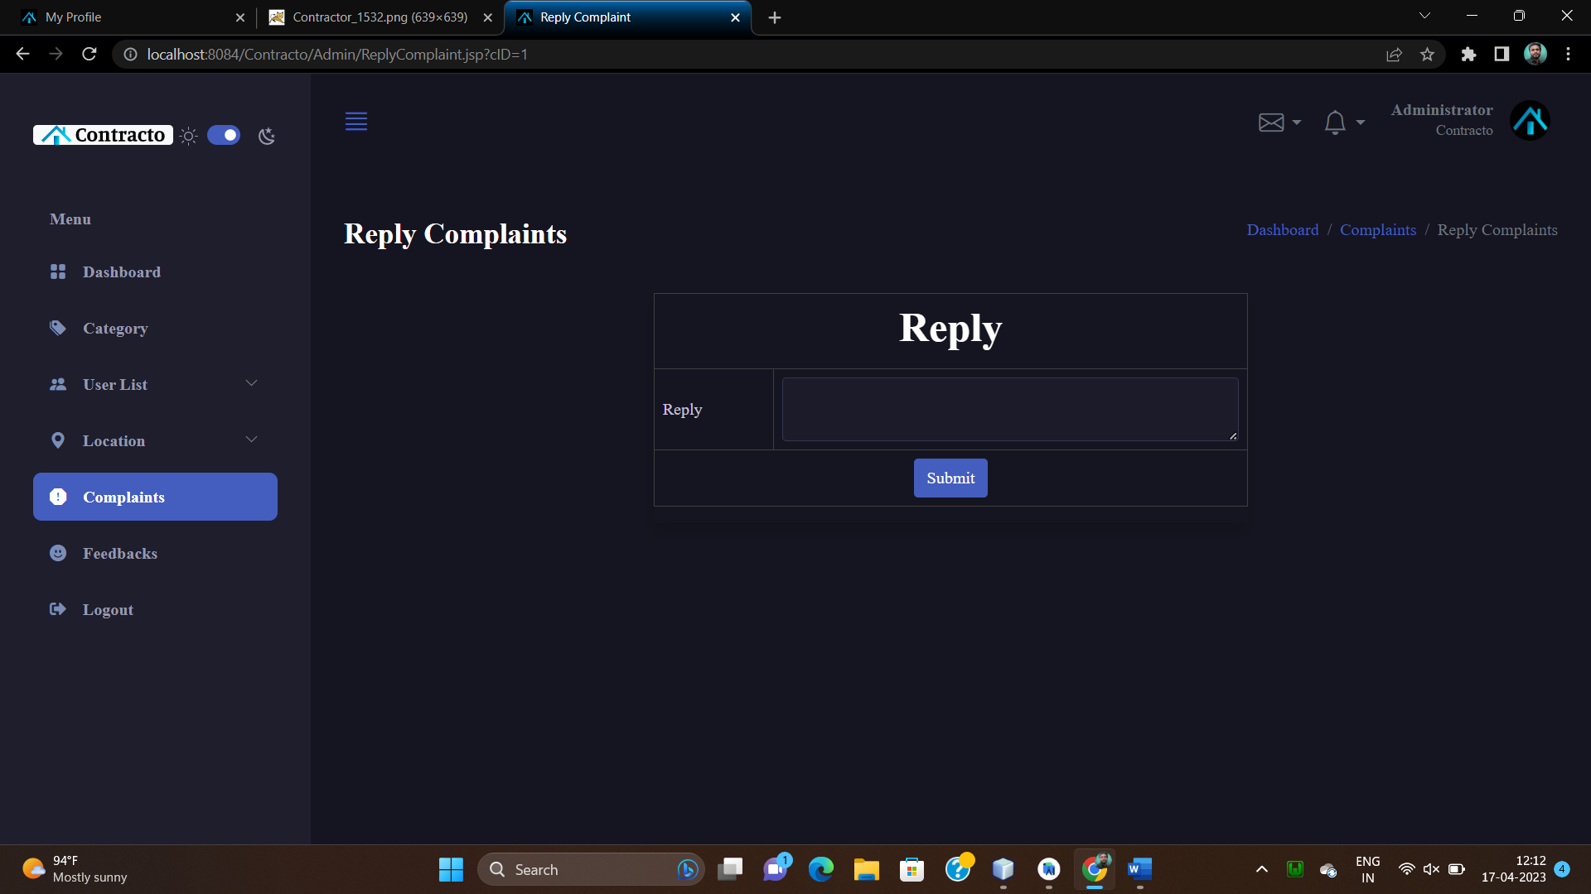

**Feedback View**

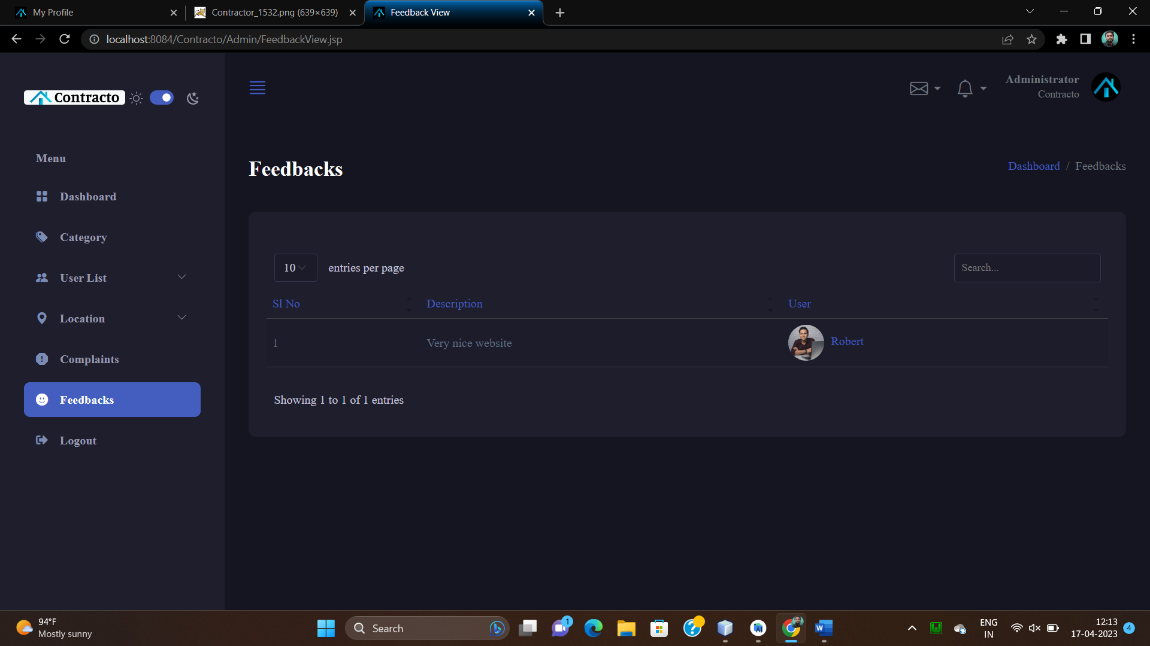

**Client Homepage**

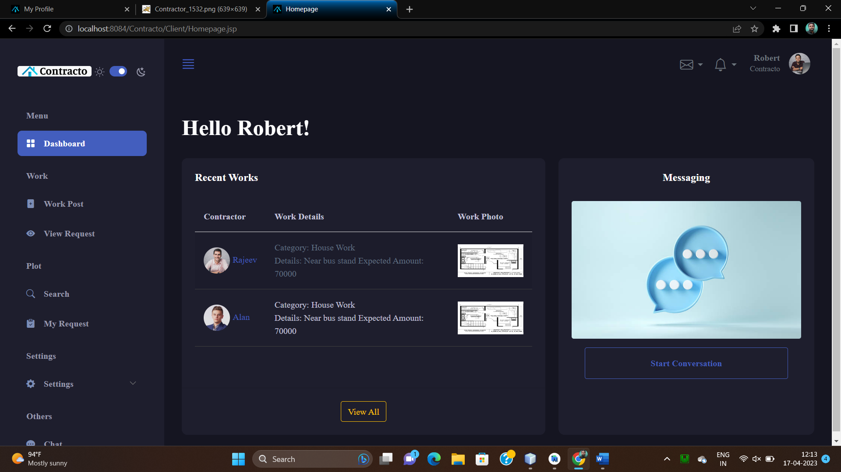

**Work Post page**

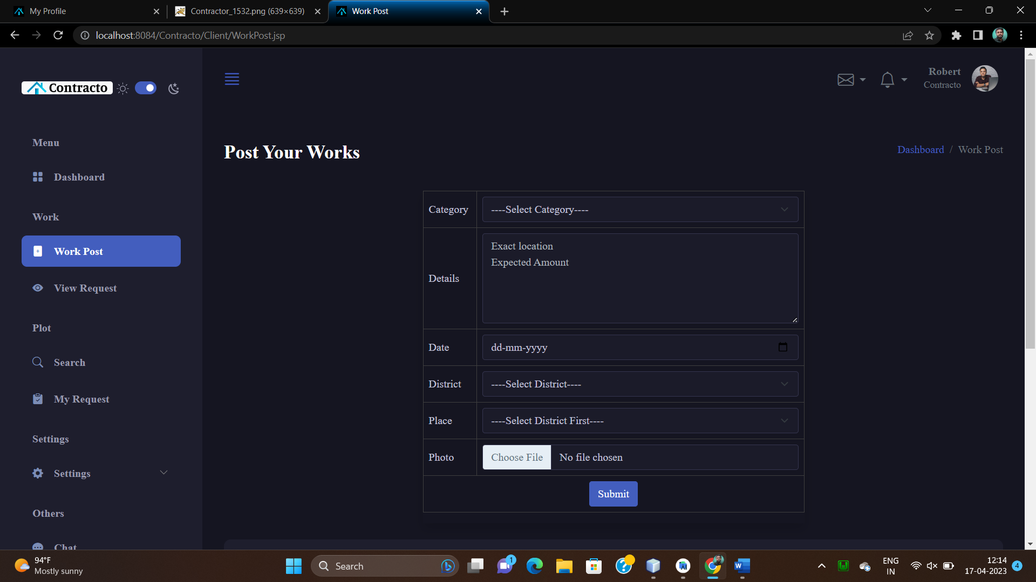

**View Work Request**

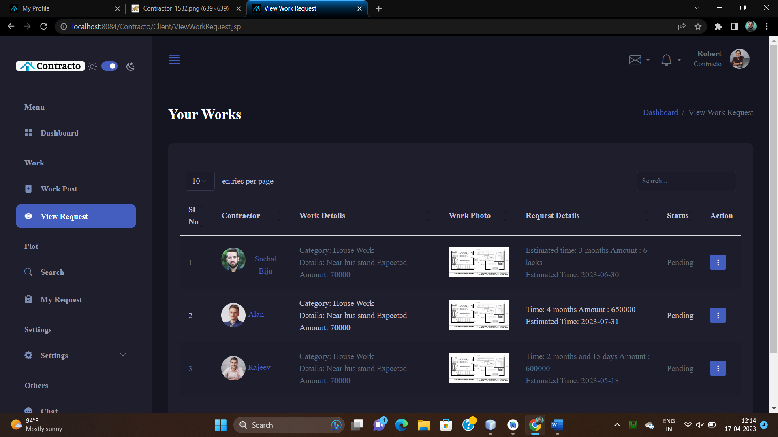

**Search Plot**

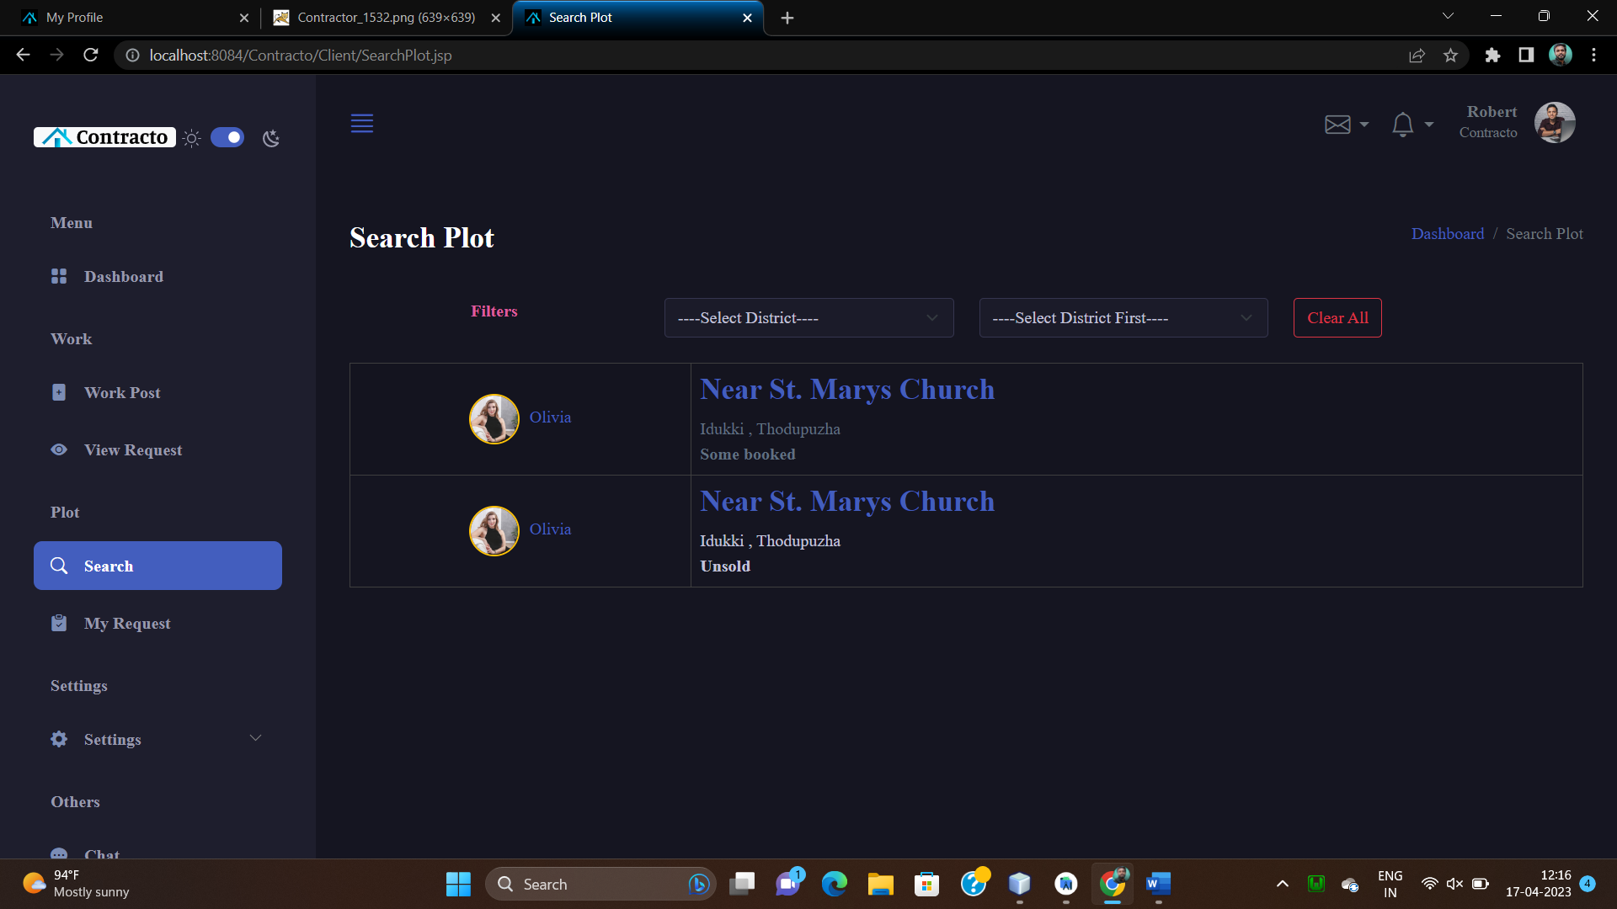

**Plot details**

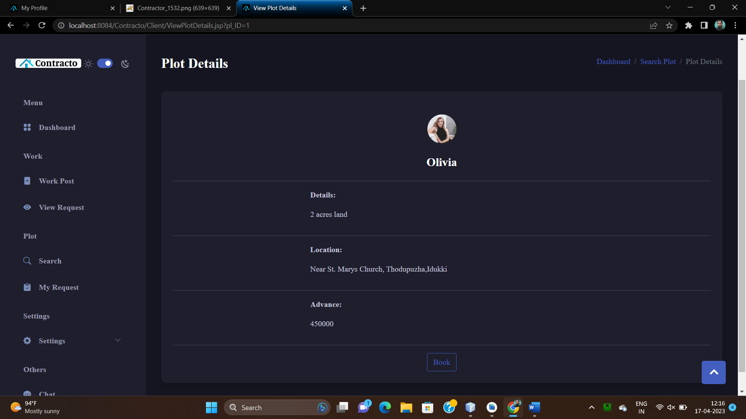

**Client Profile**

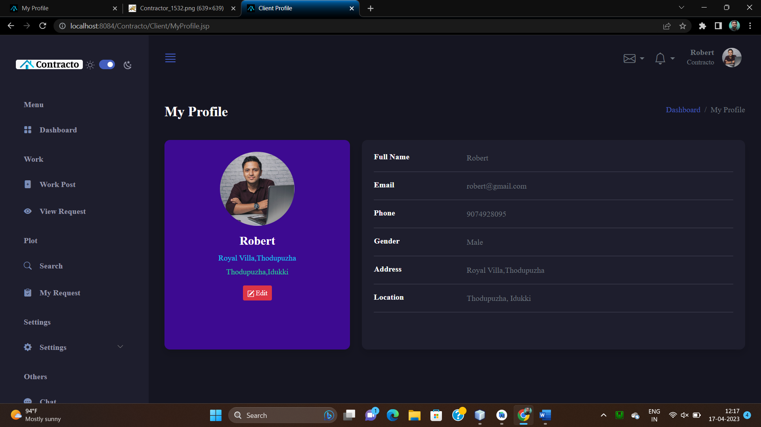

**Edit profile**

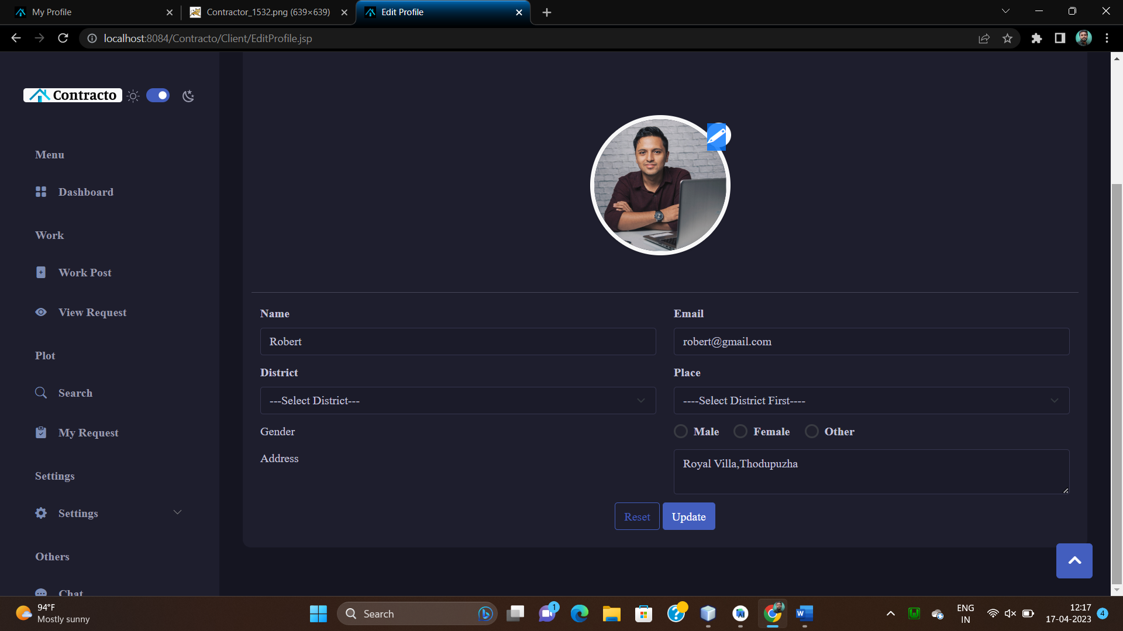

**Change Password**

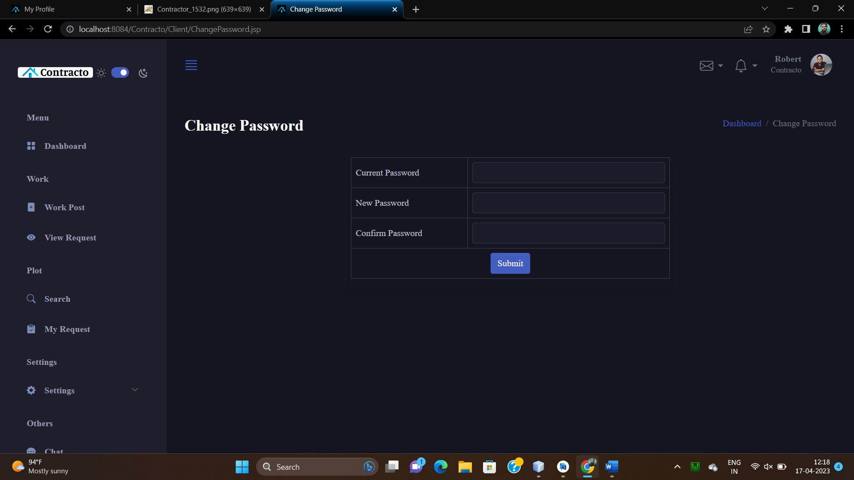

**Chatbox**

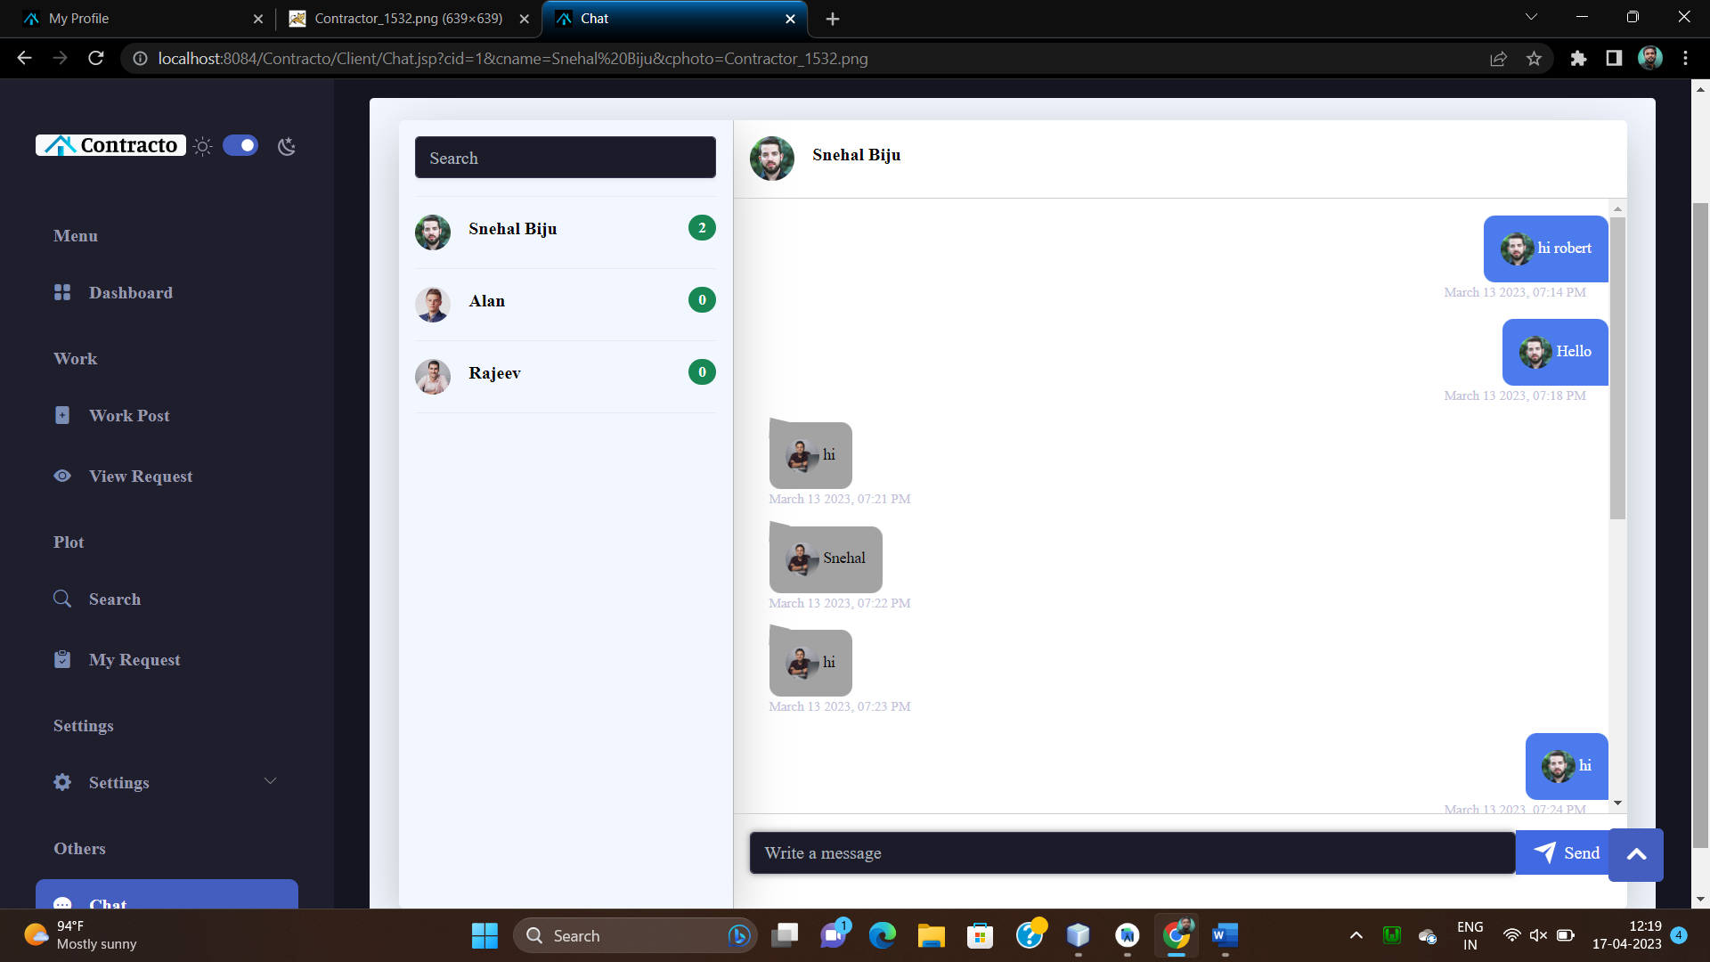

**Complaint Box**

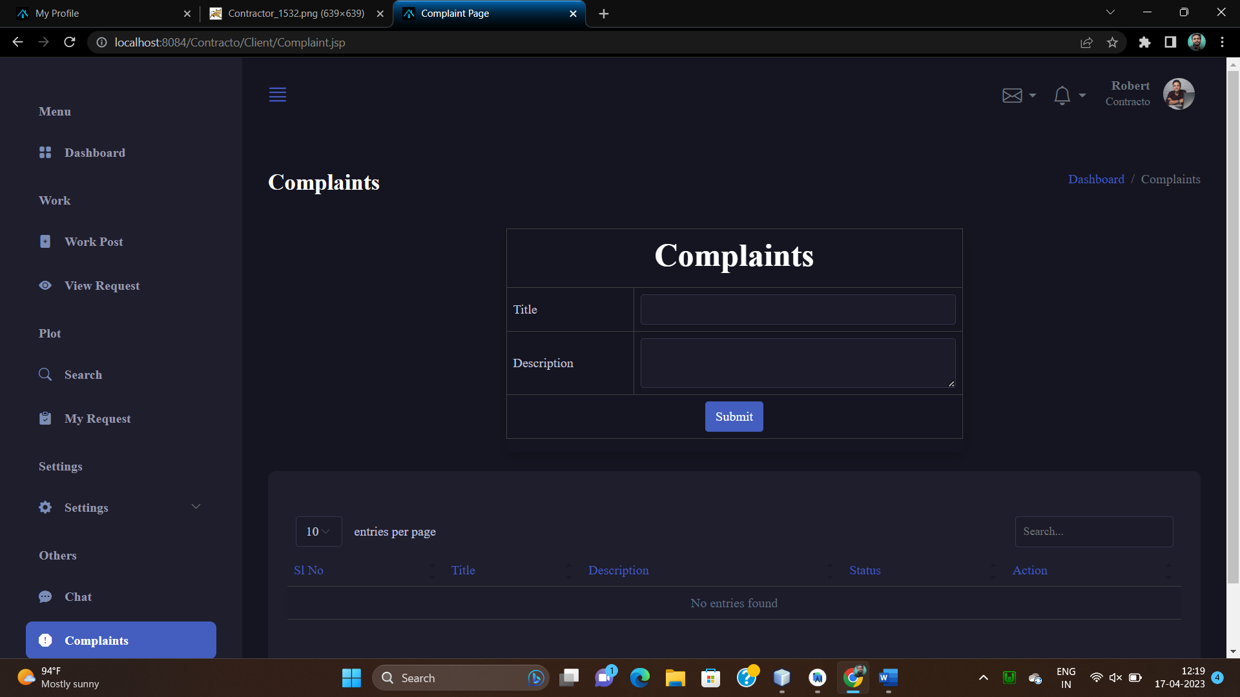

**Feedback Submission**

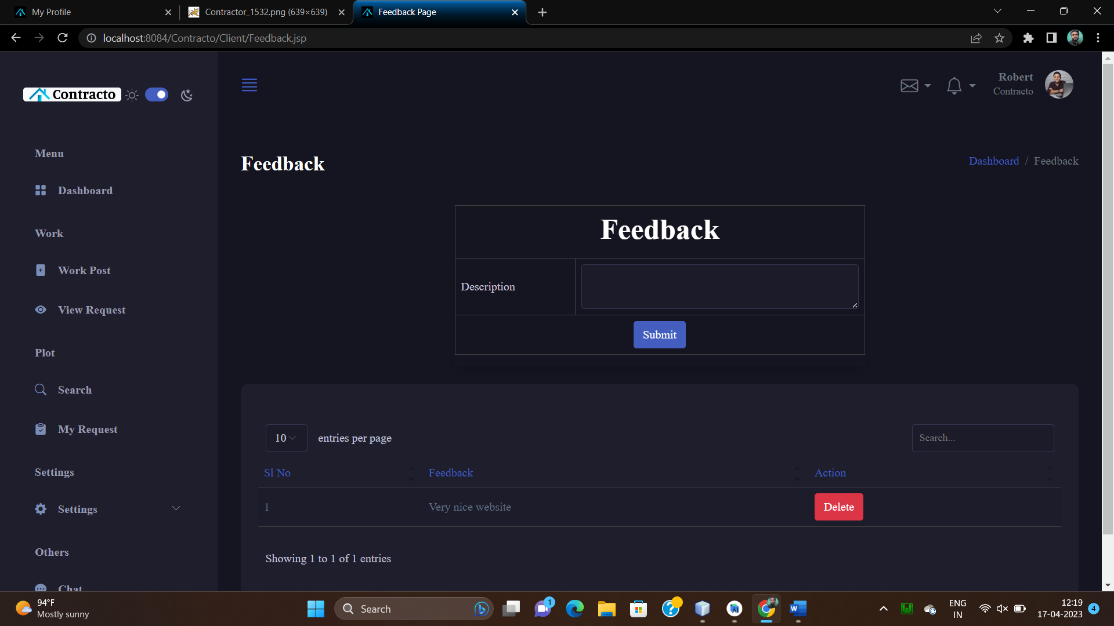

**Contractor Homepage**

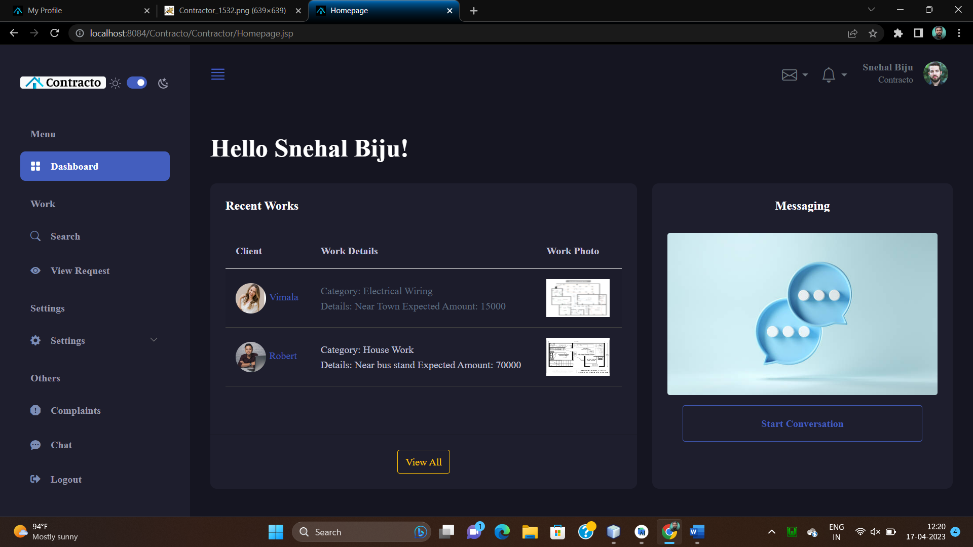

**Search Work**

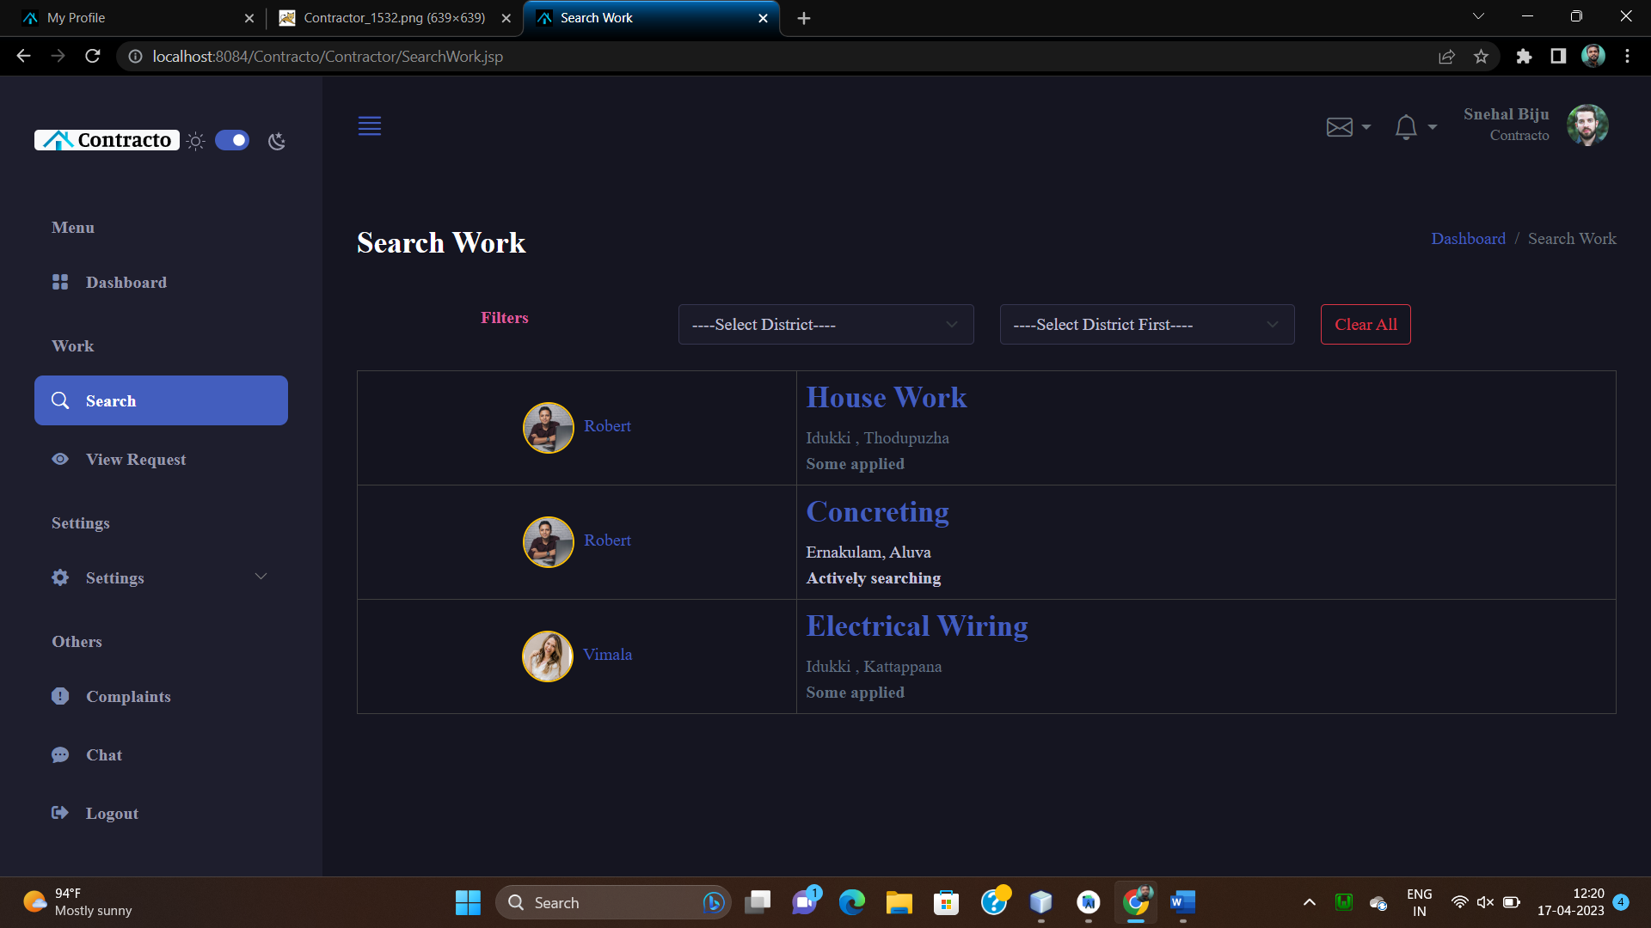

**View and Apply work**

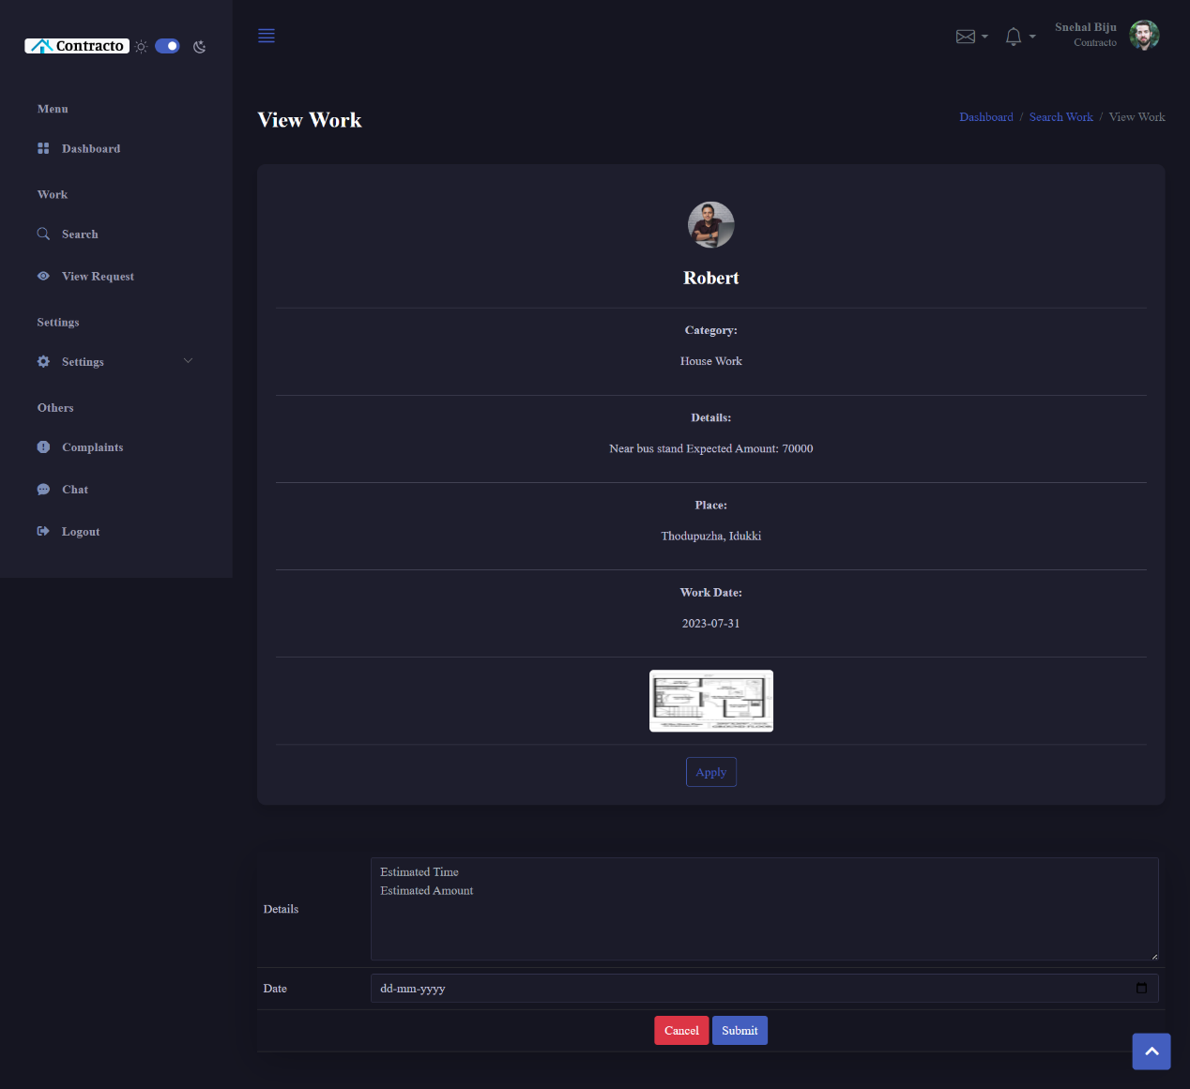

**Landlord Dashboard**

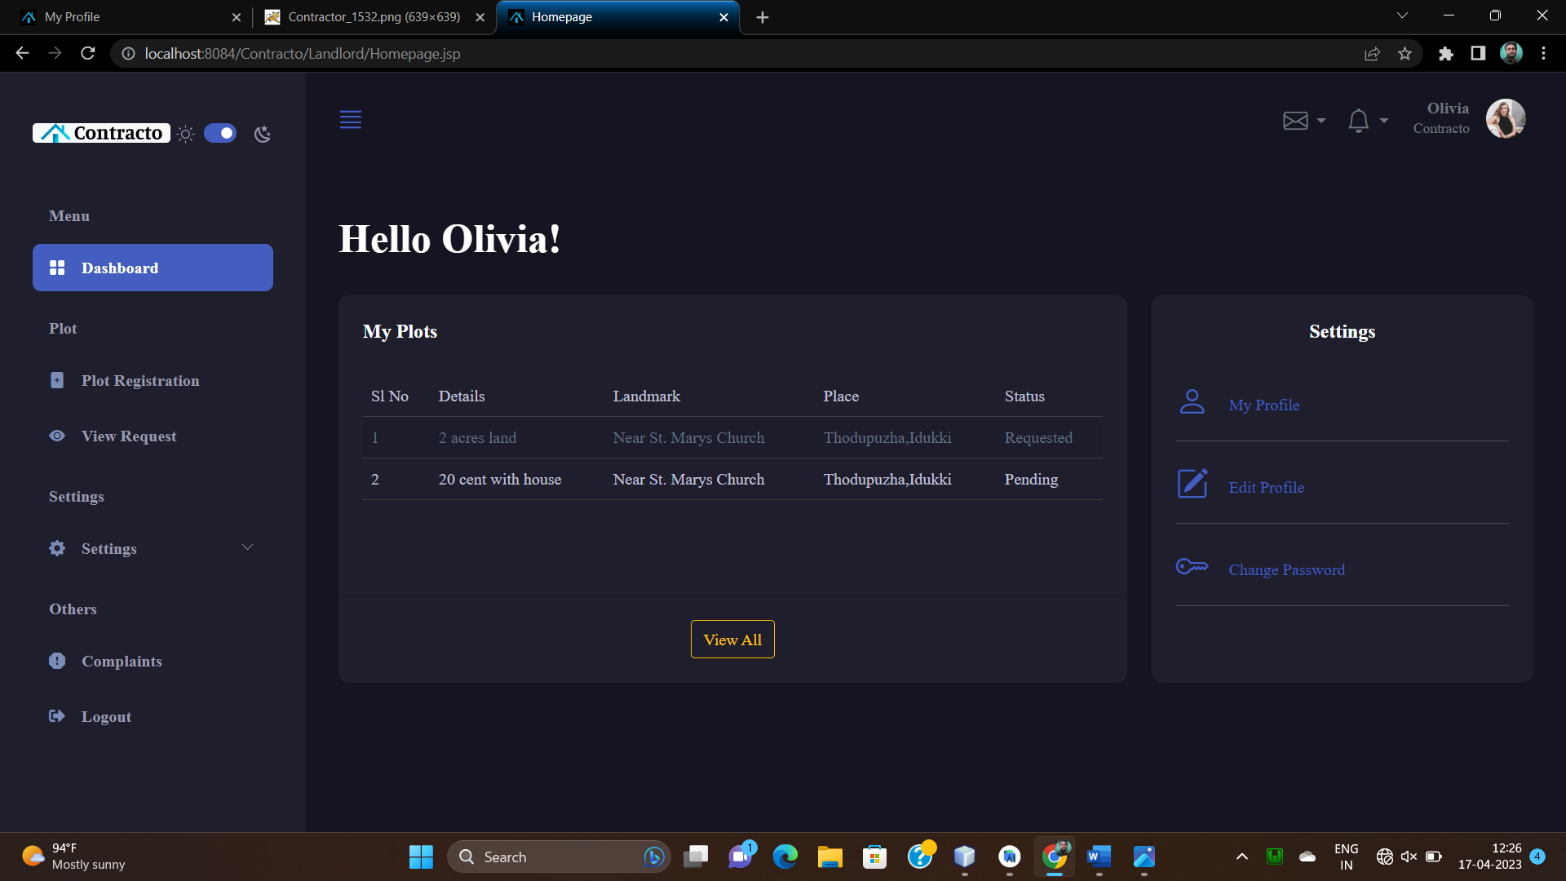

**Plot Registration**

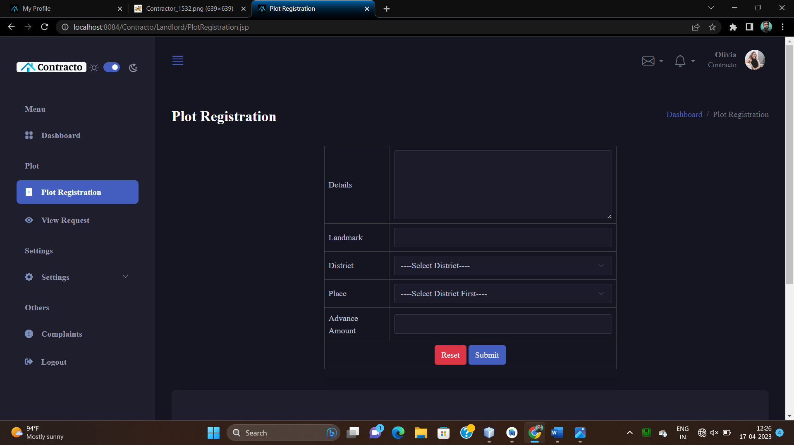

**View Plot Requests**

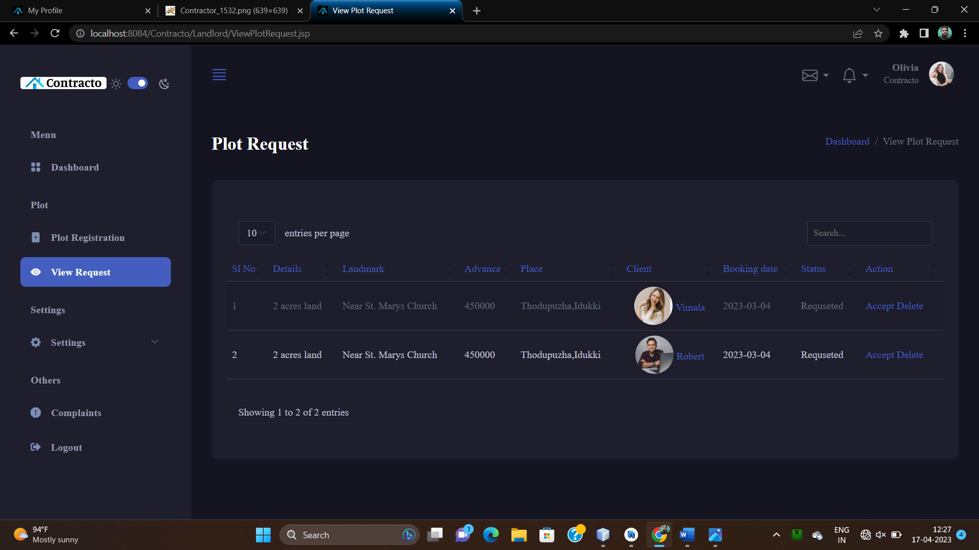

**Android App For Contractor**

|  |  |
| --- | --- |
| **User Login** | **Homepage** |

|  |  |
| --- | --- |
| **Chat Activity** | **Search Activity** |
| **View Jobs** | **View Requested Jobs** |

|  |  |
| --- | --- |
| **Profile Page** | **User Profile** |
| **Change Password** | **Complaints** |